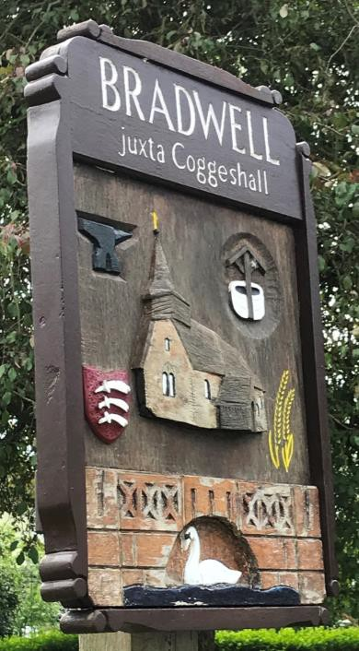

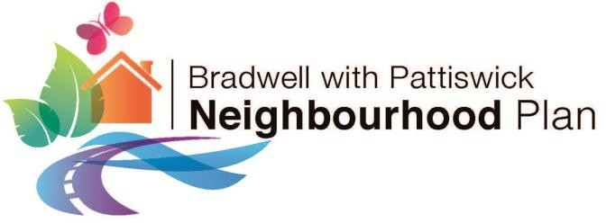

Bradwell with Pattiswick Parish Neighbourhood Plan
2024-2041

Neighbourhood Plan Review and Update
2025



Vision for Bradwell with Pattiswick Parish
Our vision for Bradwell with Pattiswick Parish is to continue to thrive, meeting the changing needs of the community whilst preserving the distinctive character, landscape and setting of this Parish which has evolved over twelve centuries of history.

1. Introduction 5
What is Neighbourhood Planning? 5
Review and update of the Bradwell with Pattiswick Parish Neighbourhood Plan 6
Regulation 14 Consultation on the Draft Neighbourhood Plan 7
How to make comments on the draft update to the Neighbourhood Plan 7
2. The Parish Today 8
Location and Context 8
Key Characteristics of Bradwell with Pattiswick Parish 10
Housing and Built Environment 12
Key issues for the future of the Parish 13
Local Planning Context 15
3. The Future of the Parish 16
Vision 16
Objectives 16
4. Neighbourhood Plan Policies 18
Environment 18
Policy 1: Protecting and Enhancing the Natural Environment and Green Infrastructure 19
Policy 2: Protection of Special and Sensitive Landscapes 23
Community Facilities and Public Open Space 25
Policy 3: Protecting and Enhancing Community Facilities and Public Open Space 25
Policy 4: Protecting Village Facilities 27
Heritage 30
Policy 5: Protecting and Enhancing the Historic Environment 30
Drainage and Flood Management 34
Policy 6: Drainage and Flood Management 35
Housing 36
Policy 7: Housing 37
Local Economy 40
Policy 8: Economy 40
Transport 43
Policy 9: Transport 44
Design 46
Policy 10: Design 46
Developer contributions 48
Policy 11: Developer Contributions 48
Implementation 51

Abbreviations 55
References 55

Annex 1: Figures
Figures 1: Map of Bradwell with Pattiswick Parish 8
Figures 2: Map of the Surrounding Area 9
Figures 3: Bradwell village settlement 9
Figures 4: Bradwell with Pattiswick Parish SWOT Analysis 14
Figures 5: Bradwell with Pattiswick Parish Natural Environment Features 21
Figures 6: Bradwell with Pattiswick: Local Greenspace 28
Figures 7: Bradwell with Pattiswick Parish Heritage Features 31

Annex 2: Tables
Table 1: Summary of 2015, 2017 and 2024 consultation responses 13
Table 2: Potential developer contributions included within the BPNP 49
Table 3: The Neighbourhood Plan Action Plan 51

Annex 3: Maps
Map 1: Local Wildlife Site: Links Wood (Bra146) 57
Map 2: Local Wildlife site: Park House Meadow (Bra157) 58
Map 3: Local Wildlife site: Blackwater Plantation West (Bra 158) 59
Map 4: Local Wildlife site: Blackwater Plantation (Bra186) 60
Map 5: Woodland: Century Piece (W1) 61
Map 6: Woodland: Orange Wood (W2) 62
Map 7: Woodland: Captains Wood (W3) 63
Map 8: Woodland: Bankfield (W4) 64
Map 9: Woodland: Bushy Warren (W5) 65
Map 10: Woodland: Artigore (W6) 66
Map 11: Woodland: Cock Pheasant Spinney (W7) 67
Map 12: Mill Pond 68
Map 13: Common Land: Land South of Holy Trinity Church 69
Map 14: Common Land: Land East of Bradwell Village 70
Map 15: Priority Habitat: The Street, Bradwell 71
Map 16: Priority Habitat: Rectory Meadow, Bradwell 72

Annex 4:
a. Cropmarks Baytree Farm and Withies Farm 73
b. Cropmarks South of Pattiswick 73
c. Cropmarks South of Whiteshill Farm 74
d. Cropmarks at Perry Green 74
e. Cropmarks North-East of Bridge Hall 75
f. Cropmarks North-East of Bradwell Hall 75
g. Blackwater Bridge 76

1. Introduction
Figure 1: Map of Bradwell with Pattiswick Parish

What is Neighbourhood Planning?

  - The 2011 Localism Act introduced new powers for local communities to produce Neighbourhood Plans, which can be used to guide and shape future development in an area. Once ’made’ (adopted), a Neighbourhood Plan forms part of the statutory Development Plan for the area, and it is used in the determination of planning applications alongside the Braintree District Local Plan.

  - Neighbourhood Plans must be subject to public consultation, examination, and local referendum prior to adoption, and policies contained within a Neighbourhood Plan should be supported by evidence base documents and sustainability appraisals as necessary. Neighbourhood Plans must meet the overall aims and objectives of the National Planning Policy Framework (NPPF), particularly in relation to supporting and promoting sustainable development.

  - Neighbourhood Plans give communities direct power to guide and shape future development. Where a Neighbourhood Plan is aligned with the strategic needs and priorities of the wider local area, neighbourhood planning can provide a powerful set of tools for local people to ensure that they get the right types of future development for their community.

  - The Planning Practice Guidance states that a Neighbourhood Plan must meet the basic conditions set out in paragraph 8(2) of Schedule 4B to the Town and Country Planning Act 1990. The submission of the final version of the Bradwell with Pattiswick Neighbourhood Plan (BPNP) to Braintree District Council will include a statement setting out how the Plan meets the requirements of the basic conditions set out below:
    - the Neighbourhood Plan has regard to national policies and advice contained in guidance issued by the Secretary of State;
    - the making of the Neighbourhood Plan contributes to the achievement of sustainable development;
    - the making of the Neighbourhood Plan is in general conformity with the strategic policies contained in the Local Plan;
    - the making of the Neighbourhood Plan does not breach, and is otherwise compatible with, EU obligations; and
    - prescribed conditions are met in relation to the Neighbourhood Plan and prescribed matters have been complied with in connection with proposals within the Neighbourhood Plan.

  - Neighbourhood Plans give local communities direct power to guide and shape the future of their Parish. The Neighbourhood Plan provides us with the opportunity to establish objectives and requirements to guide and manage future development proposals in the Parish in order to ensure that local needs are met, but also to ensure that the valued characteristics of the Parish can be maintained and protected for future generations.

  - While a Neighbourhood Plan can provide the local community with more control over the future of our Parish, there are limitations to what the Plan can do. The Plan must not conflict with European Law, national planning policy and guidance, and the strategic policies of the Braintree District Local Plan (BDLP). The Neighbourhood Plan must therefore reflect the aims and aspirations of both national and local planning policy, while providing locally specific policies in order to facilitate the right types of development, whilst protecting valuable local assets and characteristics.

Review and update of the Bradwell with Pattiswick Parish Neighbourhood Plan

  - Following public consultation, examination, and referendum, the Bradwell with Pattiswick Neighbourhood Plan was ‘made’ on 22nd July 2019. The Neighbourhood Plan has since formed part of the Development Plan, alongside the Braintree Local Plan, to inform decision making on development proposals in the area.
  - Planning Practice Guidance states there is no requirement to review or update a Neighbourhood Plan. However, neighbourhood plan policies may become out of date when they conflict with policies in a Local Plan adopted after the neighbourhood plan is made. Additionally, material considerations may be given more weight over neighbourhood planning policies which have been in place for a period of time in planning decisions. Planning Practice Guidance advises neighbourhood plan updates to take account of the latest housing need evidence.
  - Neighbourhood plan updates are divided into three types of modifications:
- Non-material modifications which do not require examination or a referendum;
- Material modifications which do not change the nature of the plan but require examination; and
- Material modifications which change the nature of the Neighbourhood Plan and require both examination and a referendum.

  - The review of the Neighbourhood Plan has to date included the following activities undertaken by Parish Council:
- Four Parish Council meetings (5th August 2024, 11th November 2024, 9th December 2024, and 13th January 2025).
- Distribution of a questionnaire to everyone living in the Parish, to which 42% of households responded.
- Meetings and discussions with partners (National Highways, Essex Highways, Police, Neighbourhood Watch, and Braintree District Council).
  - Through these activities, the Parish Council has determined that the following updates are required to the Neighbourhood Plan:
- Extended Plan period to align with the current review of the BDLP.
- Factual updates about changes in the area since 2019.
- References to new and updated documents which have been published since 2019.
- Reference to information obtained from a recent survey of the Parish.
- Updated local planning policy context, in particular referencing Sections 1 and 2 of the BDLP which have been published since 2019.
- Minor amendments to the Neighbourhood Plan objectives.
- Updates to text supporting policies where necessary to provide improved explanation and clarification of policy requirements.
- Removal of specific references to education contributions from new development. There is no need to reference these within the Plan, Essex County Council will continue to seek appropriate education contributions where appropriate irrespective of any reference to this requirement within the Neighbourhood Plan policies. The relevant guidance on education contributions within the area is the 2024 Essex County Council Developers’ Guide to Infrastructure Contributions.
- Correction of any minor errors in the Plan.
- Improved policy wording where necessary to improve people’s understanding of the policy requirements, and to support their eventual implementation.
- Clarification of the type of development outside the village settlement boundary which shall be supported, subject to the requirements of other policies within the Plan.
- The removal of completed projects, and the inclusion of new and updated projects within the Neighbourhood Plan Action Plan.
- Removal of any reference to CIL within the Plan, as to date this has not been progressed by Braintree District Council.

  - It is the view of the Parish Council that these updates to the Neighbourhood Plan introduce material modifications to the Neighbourhood Plan which, as set out within Planning Policy Guidance, require consultation and examination but are unlikely to require a referendum for the new version of the Plan to be ‘made’. These material modifications will be examined, where an examiner will determine if a referendum is required.
  - The evidence base documents associated with the Bradwell with Pattiswick Neighbourhood Plan can be viewed at: www.braintree.gov.uk/BwPNeighbourhoodPlan

Regulation 14 Consultation on the Draft Neighbourhood Plan

  - The Neighbourhood Planning (General) Regulations 2012 (as amended) require a draft Neighbourhood Plan to be subject to public consultation (Regulation
14) before the updated Plan can be submitted to a local planning authority for examination (Regulation 15/16). This Plan therefore presents the Regulation 14 consultation version of the draft update to the Bradwell with Pattiswick Neighbourhood Plan.

How to make comments on the draft update to the Neighbourhood Plan

  - Comments can be submitted in the following ways:
Post: Tony Dunn, Ballaglass Cottage, Coggeshall Road, Stisted, Braintree CM77 8AB
Email: clerktobppc@outlook.com
  - Questions or requests for further information can be submitted to:
Phone: 01376 331409
Email: clerktobppc@outlook.com

  - The consultation deadline is Wednesday 26th March 2025.

2. The Parish Today

Location and Context

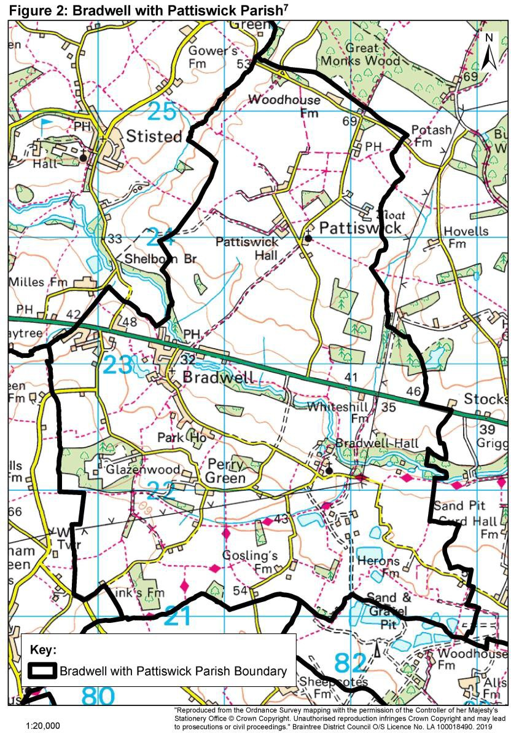
  - The Parish of Bradwell with Pattiswick is located in the District Figure 2: Map of Bradwell with Pattiswick Parishof Braintree, Essex. Bradwell with Pattiswick Parish includes the main settlement of Bradwell, the hamlets of Pattiswick and Perry Green, and a number of isolated homes on connecting roads. Bradwell village provides the main residential area of the Parish, separated from the hamlets by predominantly open agricultural fields.
Figures 1: Map of Bradwell with Pattiswick Parish

  - Bradwell is a dispersed village of around 230 dwellings, located on the A120 three miles east of Braintree. The majority of the village is located south of the A120, where there is a church, a village hall, allotments, an orchard of heritage fruit trees, and a playing field with a children’s play area and an outdoor gym. Waduds Indian restaurant and BP petrol station with associated convenience shop and cash point are located within the village on the A120.

  - Pattiswick is located north of Bradwell and the A120, and contains a small number of dispersed houses separated by
large agricultural fields. Pattiswick also contains St Mary's Church (now a private residence) and the Compasses – a wedding venue.

  - South of Bradwell is the hamlet of Perry Green, containing a small collection of houses, farm buildings and a Solar Farm. Other facilities in or close to the Parish include the Caesars Dolphin Italian restaurant, Bradwell Pit and companies which provide services such as printing, conservatory manufacture, motorcycle clothing accessories, health therapy, dress-making and dog-training. The largest employer in the Parish is Blackwater Aggregates, with around 50 employees and Indaver Integrated Waste Management Facility (IWMF) have started recruiting locally.

  - South of Perry Green is the Essex Way footpath. Regular bus services are available from Bradwell on the A120 going to Braintree, Coggeshall, Colchester and from Braintree to Chelmsford via Broomfield Hospital. The nearest train stations are located south west of the Parish at Cressing and Braintree Freeport on the Braintree Branch Line. The closest mainline stations are located south of the Parish at Kelvedon (but the road access is poor) and Witham. The most directly linked station by passenger transport is Braintree.

  - Just outside the Parish at Silver End / Rivenhall Airfield an Integrated Waste Management Facility is being constructed by Indaver – this facility includes an incineration plant and electricity generation and is due to open in 2026. There are proposals for greenhouses to grow tomatoes to satisfy up to 9% of UK demand which will capture carbon and use excess heat from the IWMF.

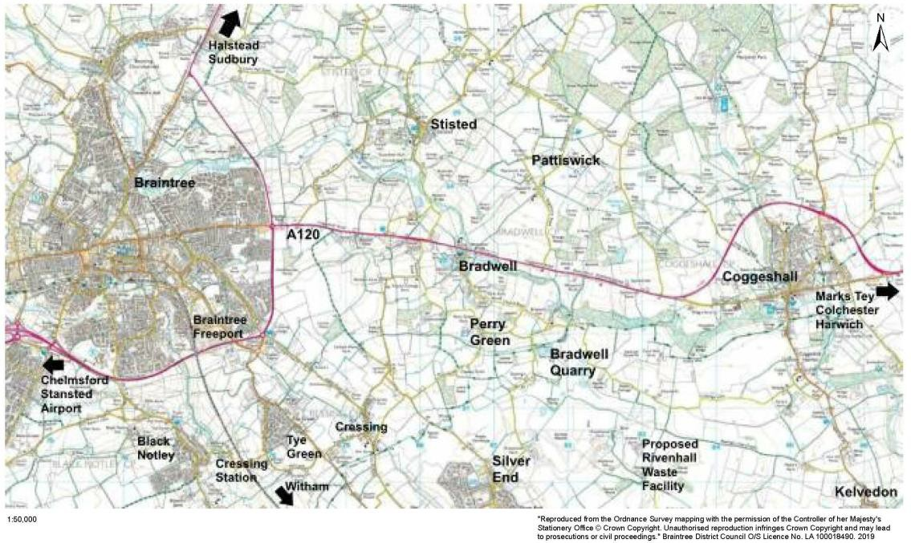
Figures 2: Map of the Surrounding Area

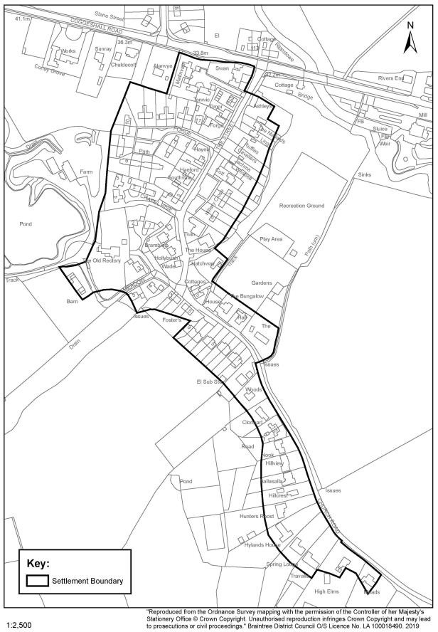
Figures 3: Bradwell village settlement

Key Characteristics of Bradwell with Pattiswick Parish

  - The Rural Community Profile for Bradwell with Pattiswick Parish (Rural Community Council for Essex, 2013 and 2024) and Annex 1 of the Parish Plan (BPPC, 2016) summarise key statistics on Bradwell with Pattiswick Parish. Conclusions drawn from these statistics have been considered in the formulation of objectives and policies for the Neighbourhood Plan. The following diagrams present the key statistics and conclusions which have been reached following an assessment of all statistical data available within the Neighbourhood Plan evidence base.

The Parish has a significantly higher proportion of residents aged 45-75 than the District and County averages.

The Parish has a significantly lower proportion of residents aged under 44 than the District and County averages.

Social

The majority of households in the Parish are financially more comfortable than in other areas of the country.
There is a lower proportion of children under 16 in the Parish in comparison to the national average.

Rates of deprivation, poverty, and benefits claimants in the Parish are significantly below national averages.

Rates of employment in the Parish are higher than District, County, and national averages.

The Parish has a significantly higher proportion of managers, directors, senior officials, and workers with a skilled trade compared to District and County averages.

Economy

Retail, manufacturing, and construction are the highest employment sectors in the Parish.
The Parish has a significantly higher proportion of self- employed workers than District, County and national averages

A higher proportion of people work from home in the Parish in comparison to the national average.

Less people access employment by public transport in the Parish in comparison to national averages.

Residents are more reliant on car use in comparison to other areas of the country. Two thirds of residents never use the bus.

Transport

The Parish has a higher proportion of households with 2 or more cars than District and County averages, and a significantly higher proportion of households with 4 or more cars.

Residents have to travel significantly further for employment in comparison to national averages. This is a trend across Essex, however Bradwell with Pattiswick Parish travel distances are also higher than the County averages.

Road distances to access a job centre, secondary school, GP surgery, and post office are further than national averages.

Connectivity
Travel times to a hospital, supermarket, employment centre, education facilities, GP surgery, and town centre are twice the average for County and national averages.

The area has relatively good accessibility to services by car, but is heavily dependent on the accident-prone A120. The Parish has access to bus services, however travel distances to services can makes accessibility difficult by sustainable modes of transport.

The Parish has a significantly higher proportion of detached dwellings than the District, County and national averages.
Property prices in Braintree are higher than the national average, but slightly lower than the regional average

There are a lower number of house moves in the Parish in comparison to national averages.

The Parish has a higher proportion of semi-detached dwellings than the District, County and national averages.

Housing and Built Environment
Only 30% of dwellings in the Parish are 1 or 2 bedroom properties. There are not many properties in the Parish appropriate for elderly people downsizing and first time buyers.

There is a significantly lower proportion of terraced housing and flats in the Parish compared to District, County and national averages.
There is a lower proportion of social housing in the Parish in comparison to District and County averages.

Key issues for the future of the Parish

  - The Parish Council undertook Parish wide consultations in 2015, 2017 and 2024. In all consultations, a questionnaire was provided to every household in the Parish, seeking views on a range of topics to inform the planning policy direction of the Neighbourhood Plan. The 2015 survey received a 44% response rate, the 2017 survey received a 25% response rate from residents. The 2024 survey received a 42% response rate

  - The Bradwell with Pattiswick Parish Neighbourhood Plan Consultation Statement and the Bradwell with Pattiswick Neighbourhood Plan Refresh 2024 Report provide a comprehensive summary of the results of the questionnaires, which identified the following key conclusions:

Table 1: Summary of 2015, 2017 and 2024 consultation responses
Positive features of the Parish
- The Parish has a sufficient quantity of open space
- The Parish has adequate well-signed public footpaths
- There is a broad mix of housing in the Parish
- There are sufficient employment opportunities in the Parish and the surrounding area
- The Parish has a good sense of community
- The Parish is perceived as a safe place to raise a family
- Quiet rural character of Bradwell village
Proposed improvements to the Parish
- Overhead cables have a detrimental impact on Bradwell village and the surrounding landscape
- On-street parking on The Street and Forge Crescent in Bradwell villages makes access difficult. Area needs more off-street parking
- Improved pavements on the A120, in Bradwell village and down to the playing field
- The safety of pedestrians within Bradwell village, particularly in the area where The Street meets Church Road
- The speed of traffic travelling through Bradwell village both on the A120, The Street and Church Road
- Introduction of a Neighbourhood Watch Scheme
- The quality and maintenance of footpaths throughout the village
Proposed Neighbourhood Plan policy recommendations
- Restrictions of HGV movements in The Street
- Road safety improvements such as 30mph speed limit on the A120, 20mph speed limit through the Village , 40mph on Church Road to the Church and speed checks
- No large scale housing development in order to protect the character of the Parish
- Very limited small scale housing development would be appropriate
- Any new housing should consist owner occupied starter homes and family homes. Flats, apartments, and terraced housing is not preferred in the Parish
- Any development must reflect and complement the rural character and heritage of the area and meet the needs of local people
- Any new development should be very energy efficient and low carbon (such as Passivhaus) and respect the design, layout, and character of existing development in the Parish
- The settlement boundaries should remain consistent with the Braintree District Local Plan
- Individual small-scale developments (minor development of around one or two houses) may be permitted outside the settlement boundaries where appropriate to meet local needs
- Protect the village centre
- New development should not result in any detrimental impact on local highway safety, and where possible improve highway safety within the Parish
- Encourage small scale employment use appropriate to a rural area, provided that it does not impact on the character of the area or the amenity of residents.

Bradwell with Pattiswick Parish Strengths, Weaknesses, Opportunities, and Threats (SWOT) Analysis

Figures 4: Bradwell with Pattiswick Parish SWOT Analysis
Strengths

Proximity of Braintree
Proximity to the strategic highway network Rural character of the area
High quality landscapes Local wildlife and biodiversity
Valued local environmental features Historic features of the Parish
Level of prosperity in the Parish Community spirit within the Parish Amount of public open space Village Hall
Availability of local employment opportunities Well-signed public footpaths
Proximity to services and facilities in nearby Coggeshall
Weaknesses

Quality of public transport
Safety of roads throughout the Parish
Lack of essential services and facilities within the Parish
Lack of provision of suitable homes for first time buyers
Lack of appropriate housing to enable for older residents to ‘downsize’
Lack of leisure facilities;
Visual impact of overhead cables
On-street parking on The Street and Forge Crescent
Quality / lack of pavements within Bradwell The safety of pedestrians within Bradwell Lack of traffic calming measures in Bradwell

Opportunities

Strategic improvements to the A120
Support for additional employment close to the Parish – IWMF and greenhouses
Protect and enhance local services and facilities
Protect and enhance local wildlife, biodiversity and environmental features

Threats

Proposals for new housing development which could threaten local character
Proposals for additional (new) mineral extraction facilities
Lack of strategic improvements to the A120
Road safety
Decline of local services and facilities Loss of younger population

Local Planning Context

  - The Neighbourhood Plan must generally conform with the strategic policies of the Local Plan for the area. Braintree District Council (BDC) adopted Section 1 of the Local Plan, a strategic plan for North Essex produced with Colchester and Tendring Councils, in February 2021. The Section 2 Local Plan, containing District-wide policies, maps, and site allocations, was adopted in July 2025. Sections 1 and 2 of the Braintree District Local Plan (BDLP), and the current Bradwell with Pattiswick Neighbourhood Plan, form the Development Plan for the area. Relevant BDLP policies are referenced in section 4 below to demonstrate linkages between the draft Neighbourhood Plan policies, and those included within the BDLP.

  - Essex County Council is the Waste Planning Authority (WPA) for the Plan area and is responsible for preparing planning policies and assessing applications for waste management development. The Essex and Southend-on-Sea Waste Local Plan (WLP) was adopted in July 2017 forming part of the statutory Development Plan and should be read alongside the Braintree Local Plan. The WLP covers the period from 2017 to 2032. It sets out where and how waste management developments can occur and contains the policies against which waste management planning applications are assessed.

  - Essex County Council is the Minerals Planning Authority for the Plan area and is responsible for preparing planning policies and assessing applications for mineral development. The Essex Minerals Local Plan 2014 (EMLP) forms part of the statutory Development Plan and should be read alongside the BDLP. Active and unworked sand and gravel deposits are subject to a Minerals Safeguarding policy, which seeks to prevent deposits being sterilised by on mineral development. Mineral Consultation Areas seek ECC to be consulted on all non- mineral related development within a distance of 250m around active quarries, mineral infrastructure and mineral deposits permitted for extraction.

3. The Future of the Parish

Vision

With support from the Rural Community Council for Essex (RCCE), the Parish Council has identified a vision for the future of the Parish to guide the aims and aspirations of the Neighbourhood Plan.
Vision for Bradwell with Pattiswick Parish
Our vision for Bradwell with Pattiswick Parish is to continue to thrive, meeting the changing needs of the community whilst preserving the distinctive character, landscape and setting of this Parish which has evolved over twelve centuries of history.

Objectives

  - To achieve the vision for Bradwell with Pattiswick Parish, the Parish Council has identified the following objectives set out within 8 topic areas.

Environment

To maintain the natural environment and rural tranquillity of the Parish To enhance the biodiversity of the Parish
To conserve the valued rural landscape of the Parish
Community facilities and public open space

To support a cohesive, supportive community
To retain and encourage the use of facilities for outdoor recreation To provide leisure facilities to meet the needs of all residents
To protect locally important areas of open space and community facilities
Heritage

To conserve and promote the heritage of the Parish

Drainage

To seek improvements to watercourses which will minimise flood risk and damage to property

Local economy

To support and encourage small scale employment uses appropriate to a rural area To encourage new business opportunities for local people
Housing

To support very small scale housing proposals which meet local needs
To encourage the provision of owner-occupied housing which meet local needs
To ensure that housing is designed to high standards (eg Passivhaus)
To support housing which respects and enhances the Parish’s heritage and character
To support proposals which strengthen and support the hamlets
Transport

To improve road safety by creating a safe road network, which is fit for purpose
To maintain an excellent network of public footpaths and public rights of way (including byways and bridleways)
To improve off-road parking facilities in The Street and Forge Crescent
To improve the provision of community and public transport within the Parish
Design

To ensure high standards of design within new development
To support design which respects and enhances the Parish’s heritage and character

4. Neighbourhood Plan Policies

  - This section introduces in detail the 8 topic areas identified within section 3, and outlines policies which will seek to deliver the Neighbourhood Plan objectives.

Environment
Objectives

To maintain the natural environment and rural tranquillity of the Parish To enhance the biodiversity of the Parish
To conserve the valued rural landscape of the Parish

Context

  - Bradwell with Pattiswick Parish has a strong rural character, with the main village of Bradwell surrounded by small dispersed hamlets and open countryside. There are four Local Wildlife Sites in the Parish:
    - Bra146 Links Wood containing Pedunculate Oak, Hornbeam, Ash and Sweet Chestnut;
    - Bra157 Park House Meadow which is a small well drained meadow;
    - Bra158 Blackwater Plantation West which provides an important riverside wildlife corridor, providing an interesting mix of woodland, tall herb marsh and riverine habitats; and
    - Bra186 Blackwater Plantation where the extensive White Willow plantation forms an important wildlife corridor along the Blackwater valley and comprises a variety of valuable of habitats.

There are two areas of Common Land:
    - South of Holy Trinity Church; and
    - East of Bradwell village.

  - These assets, together with other locally identified assets requiring protecting, are illustrated in Figure 6 below.

  - The land includes areas of dense vegetation which provides good habitats for flora and fauna. There are pockets of woodland throughout the Parish, interspersed between large agricultural fields. Countryside areas of the Parish are predominantly arable land, with field margins and hedgerows providing a habitat to a wide range of flora and fauna.

  - Bradwell with Pattiswick Parish is located on the course of the River Blackwater as it runs south east towards Coggeshall. The Parish area includes predominantly grade 2 agricultural land, with grade 3 agricultural land running through the centre of the Parish either side of the River Blackwater (see Figure 6)14.

  - The Braintree District Landscape Character Assessment15 provides an assessment of the landscape character of the entire District, and identifies two distinct landscape character areas within Bradwell with Pattiswick Parish (see Figure 6): the Blackwater River Valley; and the Silver End Farmland Plateau. The Braintree District Landscape Character Assessment identifies the following features which define the two landscape character areas:

14 www.data.gov.uk
15 CBA, Sept 2006

Blackwater River Valley:  - Shallow valley, with gently sloping sides;  - Predominantly arable farmland with some pastoral on the valley floor;  - Strong sense of place and tranquillity;  - Extensive linear poplar and willow plantations along the river banks;  - Well vegetated former sand and gravel pits also containing poplar and willow plantations;  - Good tree cover and enclosure;  - Hedgerows delineate field boundaries, with scattered hedgerow trees; and  - Settlements are well screened by deciduous trees; | Silver End Farmland Plateau:  - Rural gently undulating farmland landscape;  - Irregular medium to large predominantly arable fields;  - Hedges and hedgerow trees forming field boundaries;  - Generally open area allowing long- distance views;  - Plantations of small woodlands, which define the edges to fields in open farmland areas; and  - Dispersed settlement pattern characterised by small isolated farmsteads and villages.


  - Key relevant policies in the BDLP include:
    - Policy LPP 63 - Natural Environment and Green Infrastructure;
    - Policy LPP 64 - Protected Species, Priority Species and Priority Habitats;
    - Policy LPP 65 - Tree Protection;
    - Policy LPP 66 - Protection, Enhancement, Management and Monitoring of Biodiversity; and
    - Policy LPP 67 - Landscape Character and Features.

Policy 1: Protecting and Enhancing the Natural Environment and Green Infrastructure

  - As a rural area containing varied landscapes, open countryside, agricultural land, trees and dense hedgerows, Bradwell with Pattiswick Parish has an environment which provides prime habitats for flora and fauna. Many species within the Parish depend on the natural environment to survive. Where the built environment is expanding, and where humans continue to have a significant impact upon the ability of wildlife to survive near towns and villages, we have a responsibility to current and future generations to protect and seek opportunities to enhance biodiversity within our natural environment.

  - The Neighbourhood Plan seeks to protect the natural environment from the impact of human activity, particularly related to new development in the countryside. The Plan seeks to protect and enhance all features of the natural environment, including biodiversity, flora and fauna, local wildlife and their habitats, and key local environmental features. Where development proposals are likely to impact upon the natural environment, they will be required to clearly demonstrate how the benefits arising from the development will outweigh the negative impacts. Such benefits could include access to the countryside for recreation, creation of wildlife corridors, overall long- term net biodiversity gains, and the achievement of other objectives set out in this Plan.

  - Development proposals which will have an impact on the natural environment will be required to clearly demonstrate the potential impacts of development, preferably through an ecological assessment. Where mitigation measures are required to support new development, the Parish may consider a 'like for like' replacement, relocation and / or compensation towards the loss of habitats where it can be demonstrated that such measures will result in a net biodiversity gain for the area, and improvements to habitats in relation to quantity, quality, and connectivity. Any compensatory habitat created should be delivered as close as possible to the development site, and should be ecologically functional in advance of any loss.

  - In 2024 Government introduced a national mandatory biodiversity net gain (BNG) requirement for all new developments to demonstrate and deliver a net gain in biodiversity of 10%, resulting in more or better quality natural habitat than there was before the development. For the purposes of BNG, biodiversity is measured in standardised biodiversity units. A habitat will contain a number of biodiversity units based on features such as its size, quality, location and type. Where it is not possible to deliver 10% BNG on the development site, developers are able to deliver biodiversity gains on other land, which could involve the purchase of off-site biodiversity units being sold on the market by landowners. The creation of sites for the purposes of providing off-site biodiversity units is therefore an increasing land use across the country, supporting new developments to meet the BNG targets, and providing demonstrable benefits to the natural environment.

  - The use of land for off-site BNG would support the protection and enhancement of green infrastructure and biodiversity being sought through Policy 1 below. Through this Policy, the Parish Council will therefore support the use of land within the Parish for the purpose of providing off-site BNG.

Figures 5: Bradwell with Pattiswick Parish Natural Environment Features

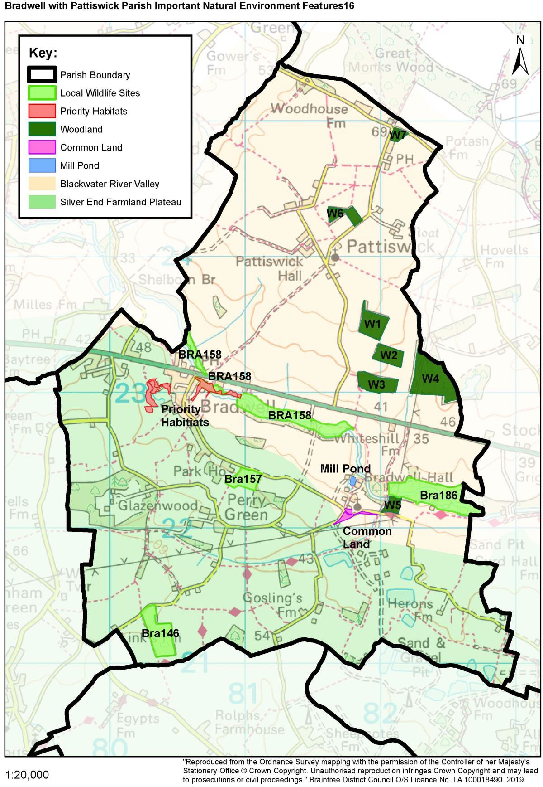

Policy 1: Protecting and Enhancing the Natural Environment and Green Infrastructure
- Development proposals should protect, and where possible, enhance the natural environment. All proposals should seek to deliver net biodiversity gain, in addition to protecting existing habitats and species. Any proposals which negatively affect, or have the potential to negatively affect, the natural environment should demonstrate that any negative impacts on biodiversity, including flora and fauna, and local wildlife (including wildlife habitats), will be adequately mitigated.

- Proposals will be encouraged that seek to enhance the green infrastructure and biodiversity of the parish by:
- Using land for the purpose of delivering off-site biodiversity net gain;
- Protecting and enhancing designated green spaces and/or creating new green/open spaces where appropriate;
- Improving the connectivity between wildlife areas and green spaces through green corridors and/or improvements to the Public Rights of Way and cycle, bridleway and footpath networks;
- Enhancing the visual characteristics and biodiversity of green spaces in close proximity to the development;
- Ensuring that landscape schemes, layouts, access and public open space provision and other amenity requirements contribute to the connectivity, maintenance and improvement of the green infrastructure network;
- Incorporating the principles of Sustainable Urban Drainage (SUDs) where appropriate, which will enhance biodiversity and ecosystems; and / or
- Incorporating the multi-functional use of local green spaces where appropriate as part of the Green Infrastructure network.

- Development proposals should protect and where possible enhance the following natural environment features within the Parish, identified within Figure 6 and Annex 3:

  - Links Wood (Bra146);
  - Park House Meadow (Bra157);
  - Blackwater Plantation West (Bra158);
  - Blackwater Plantation (Bra186)
  - The Mill Pond;
  - Common land south of Holy Trinity Church;
  - Common land east of Bradwell village;
  - Bushy Warren (ref W5);
  - Captain’s Wood (ref W3);
  - Orange Wood (ref W2);
  - Century Piece (ref W1);
  - Artigore (ref W6);
  - Cock Pheasant Spinney (ref W7);
  - Bankfield (ref W4);
  - The Street, Bradwell, Priority Habitat; and
  - Rectory Meadow, Priority Habitat.

- Development proposals which are likely to have a negative impact upon these features should demonstrate that where the benefits of development clearly outweigh any negative impacts to the nature conservation value of the feature, or to its contribution to wider biodiversity objectives.

Policy 2: Protection of Special and Sensitive Landscapes

  - The BDC Landscape Character Assessment summarised above has identified two landscape character areas within the Parish: the Blackwater River Valley; and the Silver End Farmland Plateau (see Figure 6). The landscape within these areas forms an important part of the rural character and appearance of the Parish. To maintain the special landscape character of the area it is vital that the Neighbourhood Plan seeks to protect the important features which form these landscape character areas.

Policy 2: Protection of Special and Sensitive Landscapes
Development proposals within the Blackwater River Valley or the Silver End Farmland Plateau Landscape Character Areas identified within Figure 6 should demonstrate that the proposal will:
- protect and enhance the special features and the overall character of the Landscape Character Area;
- protect and where possible improve access to open countryside within the Landscape Character Area for recreation.

  - Relevant Evidence Base Documents
Braintree District Local Plan Section 1 (2021) and Section 2 (2025)
The Braintree District Landscape Character Assessment (CBA, September 2006)

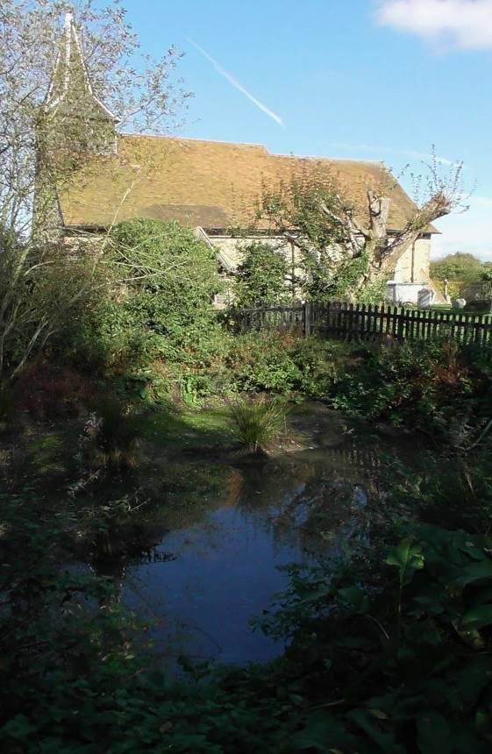
Pond on Common Land south of Holy Trinity Church

Community Facilities and Public Open Space
Objectives

To support a cohesive, supportive community
To retain and encourage the use of facilities for outdoor recreation To provide leisure facilities to meet the needs of all residents
To protect locally important areas of open space and community facilities

Context

  - Bradwell village includes a village hall on Church Road, and to the rear allotments, a playing field, a community orchard, children's play area, and an outdoor gym. These areas can be accessed from Church Road, The Street, and Coggeshall Road, and provide an important area for recreation, sports, and community events for the benefit of the whole Parish.

  - The allotments were extended in 2009, and the current provision is meeting local demand. The Village Orchard was completed in 2017, and contains sixteen Essex Heritage pear and apple trees. The children’s play area was installed in 2006, and an outdoor gym, table tennis table, and further children’s play equipment was added in 2017 and 2023/4.

  - As outlined in section 4.1, there are two areas of Common Land in the Parish (see Figure 6). Common Land is often open for public access, however these areas are physically separate from the village, and are in parts overgrown, and in other areas used for agriculture. Although these areas are recognised as community assets particularly for the benefit of flora and fauna, they are not considered to be usable areas of public open space.

  - Key relevant policies in the BDLP include:

    - Policy LPP 50 – Provision for Open Space, Sport and Recreation;
    - Policy LPP 61 – Local Community Services and Facilities; and
    - Policy LPP 78 – Infrastructure Delivery and Impact Mitigation.

Policy 3: Protecting and Enhancing Community Facilities and Public Open Space

  - Surveys undertaken by the Parish Council have identified a need for more leisure facilities within the Parish, although the most recent survey shows that satisfaction with leisure facilities has improved. Due to poor public transport links and the travel distance to access facilities outside of the Parish, it is likely that many residents are still unable to easily access a range of leisure activities which meet their needs.

  - For the purposes of Policy 3 public open space is defined in the Braintree District Council open Space Study 2016-2033 and community facilities are considered to be uses such as health, education, cultural buildings, shops, meeting places, sports venues, music venues, open spaces, public houses, and places of worship.

Policy 3: Protecting Community Facilities and Public Open Space
Developer contributions will be sought towards a range of specific projects which address local needs, including enhancements and upgrades to the playing fields in Bradwell village to ensure that the needs of local sports teams can be accommodated in the future;

Development proposals which would result in the net loss of existing community facilities or public open space should demonstrate benefits which outweigh the harm created by the loss.

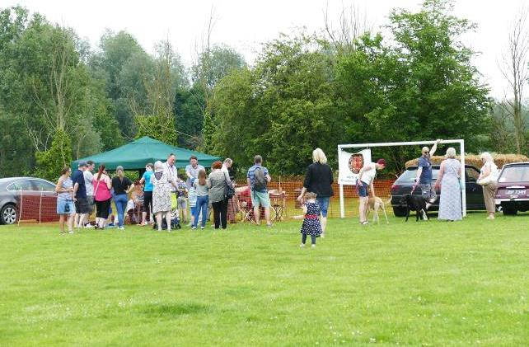

Community event at Bradwell village playing fields

Policy 4: Protecting Village Facilities

  - The playing fields at Bradwell village are an essential community facility, providing the only significant area of public open space in the Parish where sports and community events can take place alongside children's and young adult play facilities, as well as an outdoor gym. The allotments and Village Orchard are located next to the playing field and provide an alternative community facility which offer a socially inclusive, healthy and popular activity for local residents. The land has been in community use since the Victorian period and remains an essential recreational area for residents of all ages throughout the Parish. The playing fields, allotments, and Village Orchard are physically and socially at the centre of Bradwell village and the Parish, and have significant recreational value for the local community. These are therefore considered appropriately important as a community asset to warrant designation as a Local Green Space.

  - Similarly, Bradwell Village Hall provides a vital meeting place for social clubs and activities in the Parish. It is the only facility of its type in the Parish and is therefore of significant importance to local residents. At the appropriate time, therefore, the Parish Council intend to nominate Bradwell Village Hall as an Asset of Community Value, to ensure that the facility can remain available for community uses for generations to come. The production of an application to seek designation as an Asset of Community Value shortly before the lease expires is therefore included within the Neighbourhood Plan Action Plan in Table 3 below.

Policy 4: Local Green Space
Bradwell Village Playing Fields, Allotments, and Village Orchard identified in Figure 7 is designated as a Local Green Space where inappropriate development should not be approved except in very special circumstances.

Relevant Evidence Base Documents

Braintree Open Space, Sports and Recreational Facilities Study (BDC, 2016) Braintree Open Space Study (BDC, 2016)
Open Spaces Action Plan (BDC, 2017)

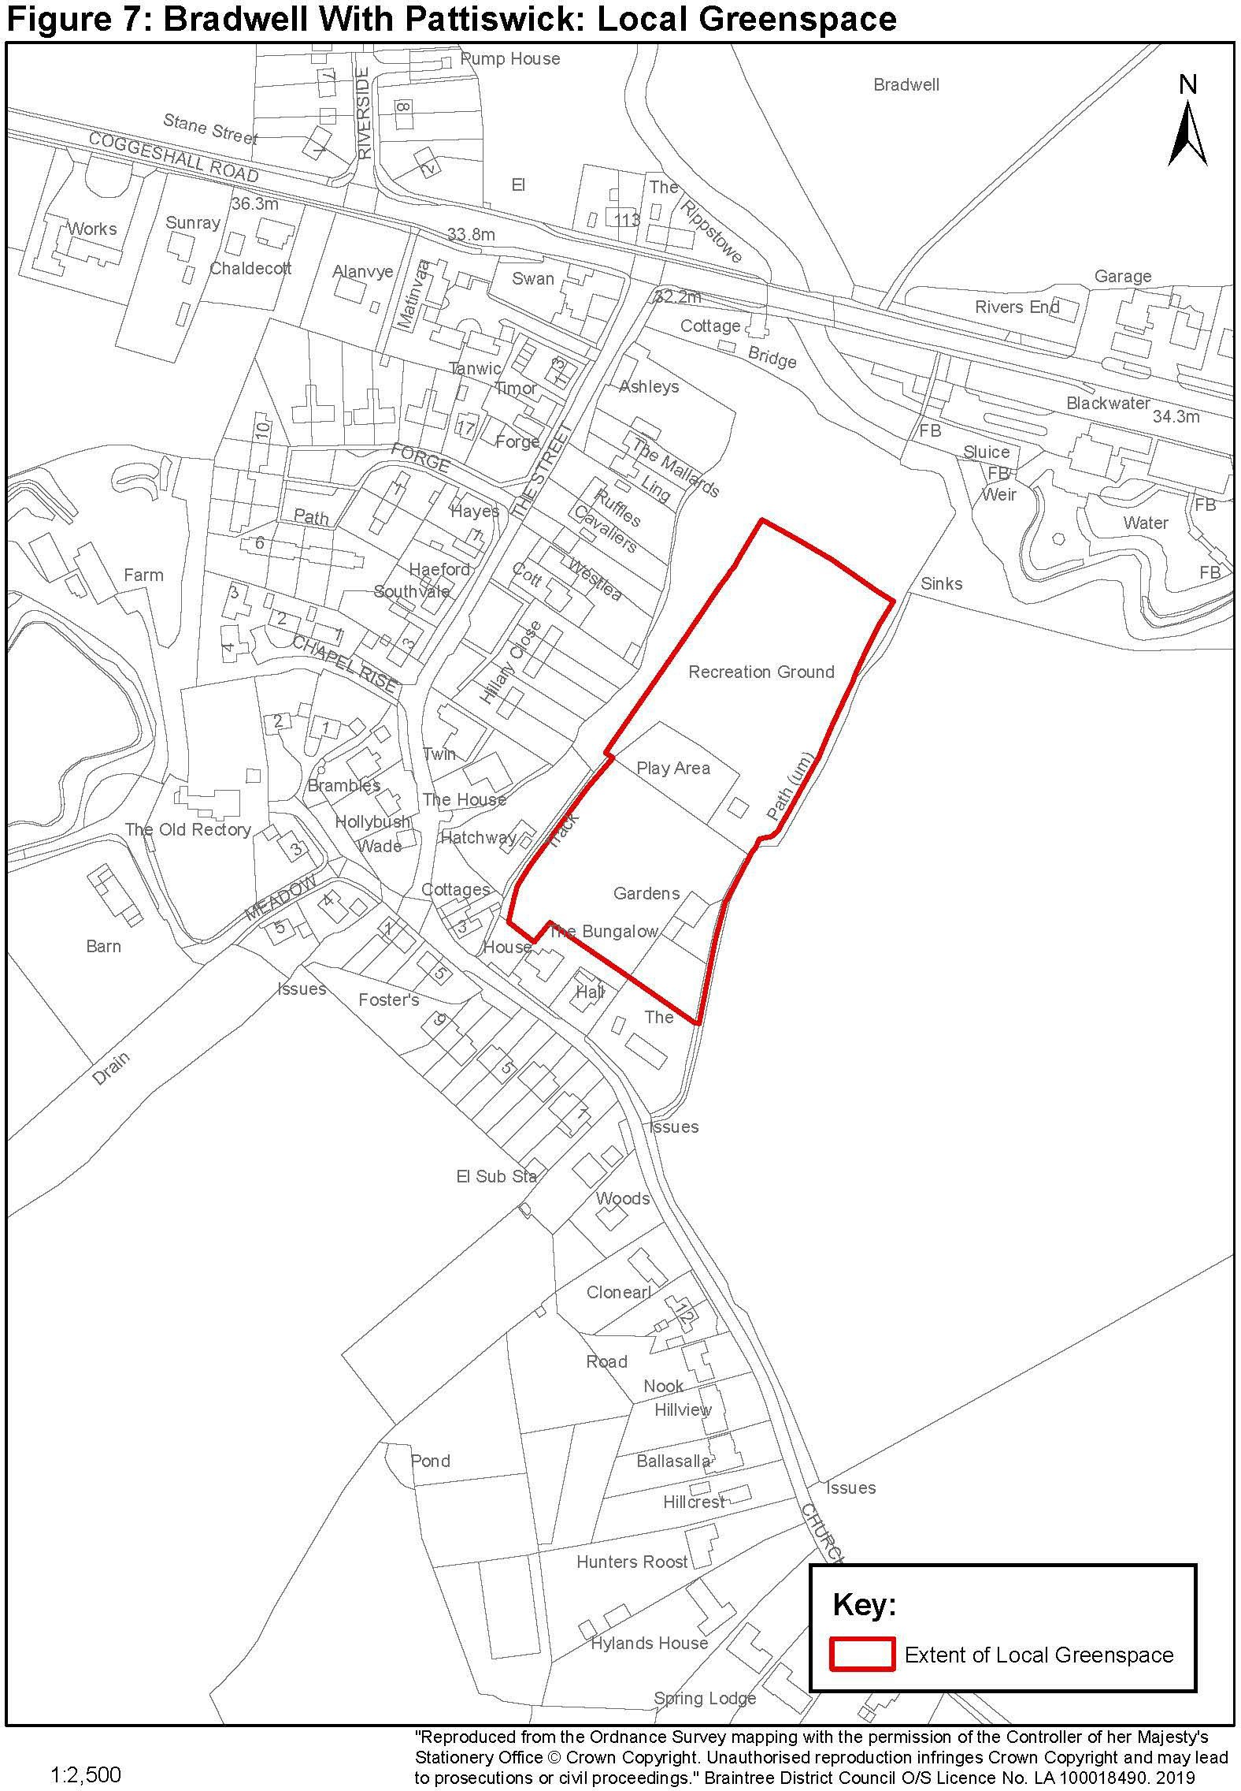
Figures 6: Bradwell with Pattiswick: Local Greenspace

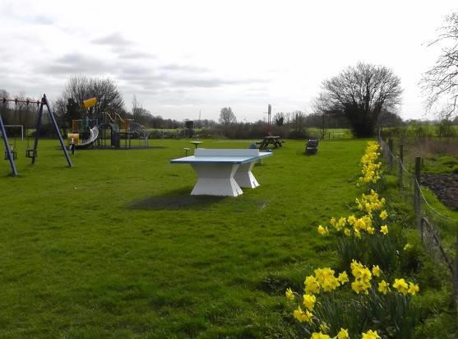
Bradwell village playing fields

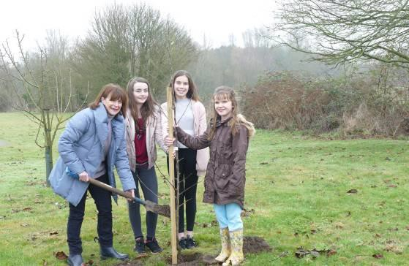
Bradwell Village Orchard

Heritage
Objectives

To conserve and promote the heritage of the Parish

Context

  - There is evidence of a settlement in Bradwell during the late Mesolithic period. There are crop marks and funerary remains suggesting a Bronze Age settlement, and excavations in the 1970s uncovered a large Iron Age ditch. There is little evidence of a Roman settlement in the area. Scattered remains in a field east of Holy Trinity Church suggest a Roman period farmstead. The A120 is however a Roman road known as Stane Street, running from Colchester to St Albans.

  - The name of Bradwell derives from Old English meaning broad well. There remains a spring a few metres north of the modern manor house of Bradwell Hall near Holy Trinity Church. In the Middle Ages the spring fed an overshot mill. The remains of the last mill on the site can still be seen in the overgrown surroundings of the millpond.

  - There are 25 Grade II listed buildings in the Parish. In addition, the Parish Church of the Holy Trinity in Bradwell village is Grade I listed and St Mary’s Church (now a private residence) in Pattiswick is Grade II* listed.

  - Key relevant policies in the BDLP include:

    - Policy LPP 57 – Heritage Assets and their settings;
    - Policy LPP 58 – Demolition of Listed Buildings or Structures; and
    - Policy LPP 63 – Archaeological Evaluation, Excavation and Recording.

Policy 5: Protecting and Enhancing the Historic Environment

  - Bradwell with Pattiswick Parish has a number of heritage assets identified within Figure 8 which should be protected, and where appropriate enhanced, for the enjoyment of current and future generations. In addition to existing ‘designated’ heritage assets, the Parish Council has identified the following ‘non-designated’ heritage assets which are of significant local importance and require ongoing protection and enhancement:

- Cropmarks Baytree Farm and Withies Farm;
- Cropmarks South of Pattiswick;
- Cropmarks South of Whiteshill Farm;
- Cropmarks at Perry Green;
- Cropmarks North-East of Bridge Hall; and
- Cropmarks North-East of Bradwell Hall.
- Blackwater Bridge See also Annex 4

Figures 7: Bradwell with Pattiswick Parish Heritage Features
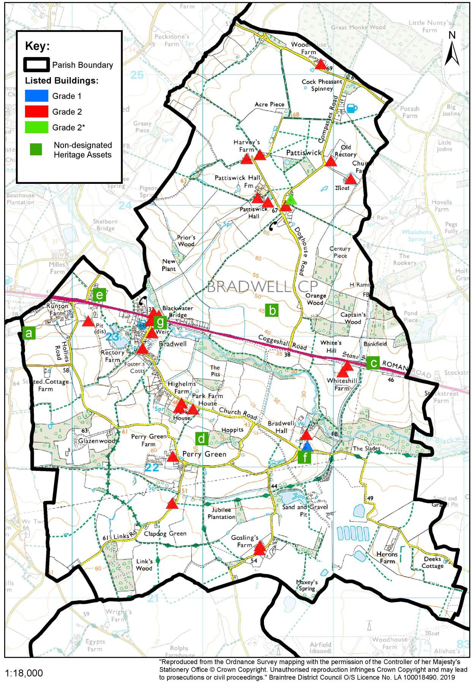

Policy 5: Protecting and Enhancing the Historic Environment
Development proposals should protect and where appropriate enhance non-designated heritage assets, including those identified in Figure 8. Any proposal which could impact on a non-designated heritage asset should demonstrate how the significance of the asset has been acknowledged and addressed.

Relevant Evidence Base Documents
Bradwell History, Bradwell with Pattiswick Parish Council, 2017
Braintree District Local Plan Section 1 (2021) and Section 2 (2025)
Essex Historic Environment Record: www.heritagegateway.org.uk

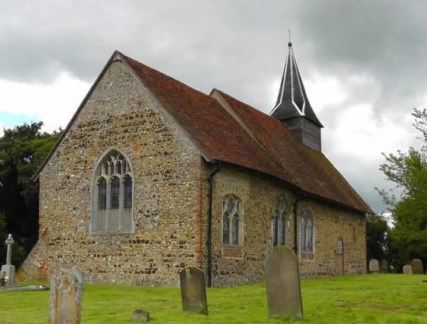
Grade I listed Holy Trinity Church, Bradwell village

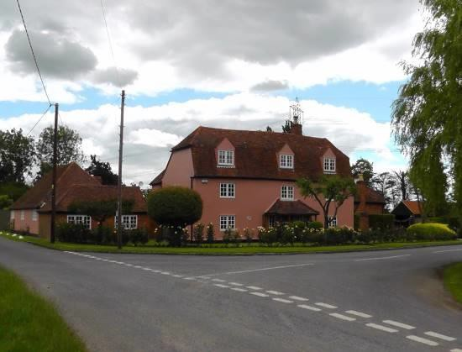
Perry Green

Drainage and Flood Management
Objectives

To seek improvements to watercourses which will minimise flood risk and damage to property

Objectives

To seek improvements to watercourses which will minimise flood risk and damage to property

Context

  - The River Blackwater and its surrounding floodplain runs through Bradwell village and the centre of the Parish. Other areas of the Parish are susceptible to surface water flooding when pipes, ditches and culverts become blocked. The following areas at risk have been identified within Bradwell village:

    - Fields to the south of Rectory Meadow and Church Road;
    - The outflow from a spring and fishing lake near Rectory Meadow which feeds into a series of ditches around Rectory Meadow, under Church Road, and into a ditch which runs along the back of housing on the eastern side of The Street, or alternatively into a ditch in Chapel Rise and then on to a drain on the western side of The Street; and
    - Outflow from fields to the south of Church Road which connects to a footpath between Cashel and 1 Church Road, and then runs under Church Road, into a culvert beside the Old School House, and down to the River Blackwater via a ditch which runs past the Village Orchard and playing fields.

  - Key relevant policies in the BDLP include:
    - Policy LPP 74 – Flooding Risk and Surface Water Drainage
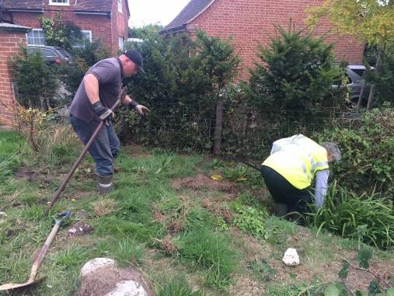
Clearing ditches within the Parish

Policy 6: Drainage and Flood Management

  - To ensure that the areas identified within Bradwell village, and any further areas identified through continued assessment, do not become at risk from surface water flooding, the Parish Council will work with Essex County Council and relevant landowners to ensure the appropriate maintenance of these watercourses. A greater understanding of watercourses throughout the Parish will support the future management of surface water flooding. The Parish Council has worked with Essex County Council as the Lead Local Flood Authority to document watercourses in the area and identify where improvements are required to reduce future flood risk. This project was called 'Where does water go'.

Policy 6: Drainage and Flood Management
Development proposals should where appropriate avoid and reduce the risk of flooding (including fluvial and surface) on site and elsewhere in the catchment, and manage water and waste water discharge.

Relevant Evidence Base Documents
Braintree District Local Plan Section 1 (2021) and Section 2 (2025)
Braintree District Council Water Cycle Study (AECOM, March 2017)

Housing
Objectives

To support small scale housing proposals which meet local needs To encourage the provision of owner-occupied housing
To provide housing which meets the changing needs of the Parish To ensure that housing is designed to high standards
To support housing which respects and enhances the Parish’s heritage and character To support proposals which strengthen and support the hamlets

To support small scale housing proposals which meet local needs To encourage the provision of owner-occupied housing
To provide housing which meets the changing needs of the Parish To ensure that housing is designed to high standards
To support housing which respects and enhances the Parish’s heritage and character To support proposals which strengthen and support the hamlets

Context

  - Housing statistics for the Parish assist in understanding the type and status of housing currently available within the area, and the potential housing needs of the Parish in the future. In comparison to national and county averages, research on the Parish's existing housing and social characteristics has identified that:
    - Braintree District property prices are higher than the national average, but slightly lower than the regional average.
    - There are a low number of house moves in the Parish.
    - There is a low proportion of social housing in the Parish.
    - Dwellings in the Parish are predominantly semi-detached and detached. The Parish has a low proportion of terraced properties and flats.
    - The Parish has a high proportion of people aged 45-75 years of age.
    - 25% of the population are over 65 years and even more are retired
    - The proportion of the population who are aged 65+ has increased since 2001, changing from 11.1% to 25.05%.
    - The Parish has a high proportion of people that work from home.
    - Dwellings in the Parish are predominantly 3 or more bedroom properties. There are few 1 and 2 bedroom properties.
    - Many properties have been extended to provide additional bedrooms etc

  - The public consultations undertaken in 2015, 2017 and 2024 included questions on housing needs in the area, and residents’ views of the types of houses that should be provided in the Parish. The consultations identified that;
    - There is considered to be a broad mix of existing housing in the Parish;
    - There is a need for appropriate properties for young people to rent or buy;
    - There is a need for appropriate properties for older residents to downsize;
    - Large scale housing developments would not be consistent with the rural character of the area. Any new development should be of a small scale (one or two houses);
    - Any new housing should consist of owner occupied starter homes and family homes. Flats, apartments, and terraced housing is not preferred in the Parish;
    - Any development must reflect and complement the rural character and history of the area and meet the needs of local people;
    - New developments should be very energy efficient (Passivhaus) and respect the design and character of existing development in the Parish; and
    - The settlement boundaries should remain consistent with the BDLP.

  - The public consultations identified that local residents do not consider large scale housing development to be appropriate or needed within the Parish. The BDLP will ensure that the objectively assessed housing needs for the local area will be met in full. However, it is recognised that some small scale new residential development can support the needs of the

  - Parish and help strengthen communities within hamlets. This proposed scale of development does not require amendments to settlement boundaries or the allocation of land for housing. This level of growth will come forward naturally over time as ‘windfall’ development. However, this policy will guide proposals for new housing in the area to ensure that proposals are appropriate and meet the needs and requirements of the Parish.

  - The public consultations identified that local residents do not consider large scale housing development to be appropriate or needed within the Parish. The BDLP will ensure that the objectively assessed housing needs for the local area will be met in full. However, it is recognised that some small scale new residential development can support the needs of the Parish and help strengthen communities within hamlets. This proposed scale of development does not require amendments to settlement boundaries or the allocation of land for housing. This level of growth will come forward naturally over time as ‘windfall’ development. However, this policy will guide proposals for new housing in the area to ensure that proposals are appropriate and meet the needs and requirements of the Parish.

  - There is a high proportion of older residents in the Parish, many who are living in large family homes which will become available in time. Some older residents seek opportunities to ‘downsize’ to accommodation of a more appropriate size and form to meet their needs. Additional smaller properties are also required for first time buyers, where local residents have highlighted a need for starter homes. Alterations and extensions over time to the existing housing stock in the Parish has led to a reduction in the provision of two and three-bedroom properties. Additional smaller properties would therefore be beneficial to the housing stock of the area.

  - There is significant housing need in Braintree District, where waiting lists for social housing are increasing beyond supply. Although there is a low proportion of social housing within the Parish, this has not been identified within consultations as an essential need for the Parish at this time. However, where affordable homes are required, these should be provided in accordance with BDLP policies LPP 31 and LPP 32.

  - Apart from one cul-de-sac west of the River Blackwater, a linear form of development follows the A120 to the edge of Bradwell village next to the BP garage. Residential development in this area is generally consistent with the rest of the village, with a mixture of detached and semi-detached low-density dwellings set back from the road and on predominantly large plots.

  - Key relevant policies in the BDLP include:
    - Policy LPP 16 – Housing Provision and Delivery;
    - Policy LPP 31 – Affordable Housing;
    - Policy LPP 32 – Affordable Housing in Rural Areas;
    - Policy LPP 33 – Specialist Housing; and
    - Policy LPP 35 – Housing Mix, Density and Accessibility.

Policy 7: Housing

  - There is a wide range of housing types throughout the Parish, however there may be a need for a greater proportion of smaller dwellings and starter homes to provide a better balance of housing types which will serve the needs of both the younger and older population. New residential development in the Parish should be very energy efficient (Passivhaus) and respond positively to the design, layout, scale, character, and appearance of existing development within the vicinity of any proposal site, and the rural character of the Parish.

  - All residential development, extensions and conversions considered under Policy 7 shall also need to be compatible with development plan policies, including those relating to the quality of design and protection of the countryside.

Policy 7: Housing
- Proposals for residential development will be supported where the proposed development:

  - Is located within defined settlement boundaries;
  - Includes housing types and tenures which meet the current and future housing needs of the Parish taking into account the existing housing stock. Proposals should ensure an appropriate housing mix;
  - Contributes positively to the existing rural character and appearance of the area;
  - Reflects and responds positively to the scale, design, density and layout of existing development in the surrounding area, and will not result in significant harm to neighbouring residential amenity;
  - Will not result in significant harm to heritage assets (both designated and non- designated) in the surrounding area;
  - Will not result in any detrimental impact on local highway safety, and where possible improves highway safety within the Parish; and
  - Protects and enhances important features of the natural environment and biodiversity of the site and its surrounds;

- Development proposals for small scale residential development and extensions and conversions for residential use outside the Bradwell village settlement boundary shall be supported as an exception to planning policies where they;

- Can demonstrate a significant contribution towards maintaining the future viability and sustainability of the adjacent settlement;
- Meet local housing needs, including affordable housing;
- Are adjacent to an existing settlement or hamlet; and
- Continue the predominantly linear existing built form of Bradwell Village along the A120 Coggeshall Road and The Street, and avoid any extensions of the Village into the countryside from Church Road, Rectory Meadow, or Hollies Road.

Relevant Evidence Base Documents

Property Inventory, Bradwell with Pattiswick Parish Council, 2017
Rural Community Profile for Bradwell Parish (Rural Community Council for Essex (RCCE), October 2013)
United Kingdom Census 2011 (Office of National Statistics, July 2012)

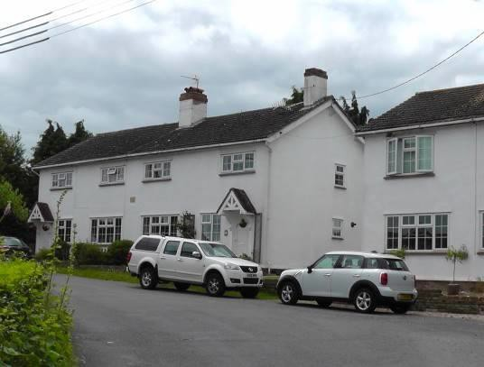

Cottages in Church Road, Bradwell village

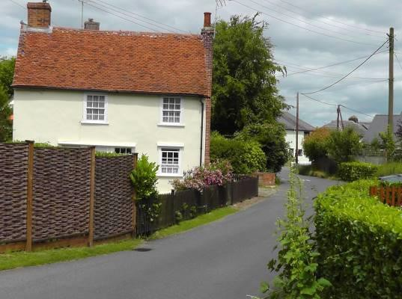
Tippetts Wade

Local Economy
Objectives

To support and encourage small scale employment uses appropriate to a rural area To encourage new business opportunities for local people

To support and encourage small scale employment uses appropriate to a rural area To encourage new business opportunities for local people

Context

  - An assessment of statistical information on the Parish highlighted that in comparison to national averages, Bradwell with Pattiswick Parish has a high proportion of self-employed workers and people that work from home, although not necessarily at home. The Parish has a high rate of employment, with most residents working as managers, directors, and senior officials within the retail, manufacturing, and construction sectors. The Parish contains a high number of workers with a skilled trade.

  - Residents in the Parish travel further to access employment in comparison to national and county averages. This is linked to the Parish's good access to surrounding employment centres at Braintree, Colchester, Chelmsford, and beyond to London through the A120, A12, and rail from train stations at Kelvedon, Witham, Cressing and Braintree. Although travel distances could suggest that there may be insufficient employment opportunities within the Parish and immediate surrounding area, the results of public consultation concluded that there are sufficient employment opportunities in the Parish.

  - Currently the Parish contains a range of small employers which provide services such as printing, conservatory manufacture, motorcycle clothing accessories, health therapy, dress-making and dog-training. The largest employer in the Parish is Blackwater Aggregates, with around 50 employees. The IWMF and associated greenhouses will provide new employment opportunities and Indaver are keen to recruit locally.

  - Key relevant policies in the BDLP include:
    - Policy LPP 7 – Rural Enterprise

Policy 8: Economy

  - The results of public consultation concluded that additional small-scale employment uses would be appropriate in the Parish where they relate well to the rural character of the area, and do not have a detrimental impact on the residential amenity of existing residents. The high proportion of self-employed skilled tradesman and working from home businesses in the Parish demonstrates that this is an important and successful part of the Parish economy. The Parish Council therefore seeks to support existing, and encourage new, small-scale skilled trade and home-working businesses in the Parish.

Policy 8: Economy
- Employment generating development proposals will be supported which:

  - enable new small-scale businesses to locate within the Parish, particularly related to self-employed skilled trades and home-working businesses;
  - protect and support existing businesses within the Parish;
  - provide benefits to the local economy and community which outweigh any harmful impacts of the proposals;
  - are located in areas which are accessible to the surrounding transport network without having a significantly detrimental impact on levels of traffic or congestion in the Parish;
  - will not result in a significant increase in HGV traffic on non-strategic routes within the Parish;
  - will not detrimentally impact upon residential amenity, health, and quality of life of existing residents;
  - contribute positively to the existing rural character and appearance of the area as described in the Village Design Statement;
  - would not result in significant harm to heritage assets (designated or non- designated) in the surrounding area;
  - protect and enhance important features of the natural environment and biodiversity of the site and its surrounds; and
  - use materials which preserve and enhance the character of the area.

- All new residential and commercial developments should be designed to be served by a fast and reliable broadband connection to the premises. Connection should include the installation of appropriate cabling within the homes or business units as well as a fully enabled connection of the developed areas to the full main telecommunications network to provide the fastest available broadband access.

Relevant Evidence Base Documents

Rural Community Profile for Bradwell Parish (Rural Community Council for Essex (RCCE), October 2013)
United Kingdom Census 2011 (Office of National Statistics, July 2012)

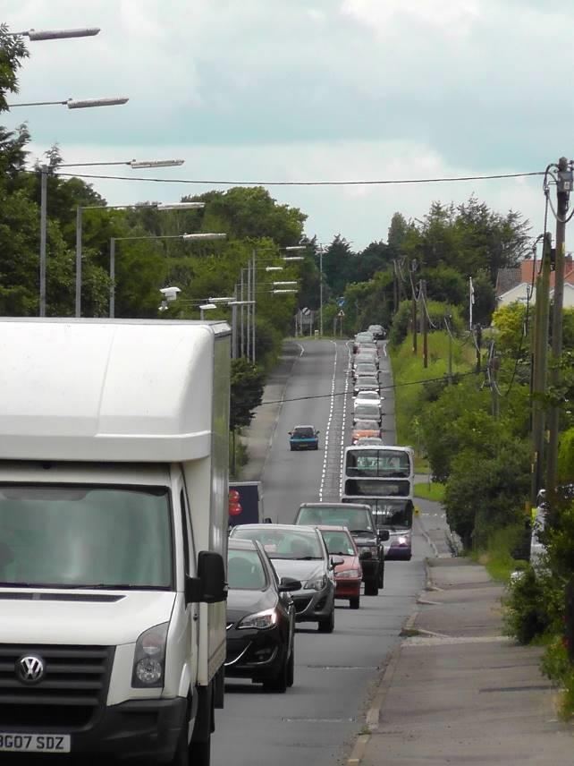

The A120 within Bradwell village

Transport
Objectives

To improve road safety by creating a safe road network, which is fit for purpose
To maintain an excellent network of public footpaths and public rights of way (including byways and bridleways)
To improve off-road parking facilities in The Street and Forge Crescent To improve the provision of community and public transport

Objectives

To improve road safety by creating a safe road network, which is fit for purpose
To maintain an excellent network of public footpaths and public rights of way (including byways and bridleways)
To improve off-road parking facilities in The Street and Forge Crescent To improve the provision of community and public transport

Context

  - Statistical information on the Parish has identified that in comparison to national and county averages, residents in Bradwell with Pattiswick Parish are highly reliant on car use to access employment, services and facilities, and residents have to travel further to access employment. However, in relation to journey times to access services and facilities, the Parish has relatively good accessibility to services and facilities in the surrounding area.

  - The accident-prone A120 runs through the Parish and is the main access route for freight and passengers between east coast ports at Harwich and Felixstowe, Stansted Airport and the M11. Due to the level of international transport, the route is known as a ‘Trans-European Network’. The A120 also provides an important local role as the main access route to the regional centres of Braintree and Colchester, linking surrounding rural areas to employment, services and facilities. The A120 is a dual carriageway between the M11 and Braintree, however beyond Braintree going east the A120 becomes single carriageway until it joins the A12 at Marks Tey. The A120 east of Braintree is operating beyond the capacity of the road for 5.75 hours per day, and therefore suffers from significant congestion at peak periods, poor journey time reliability, a high collision rate, and poor resilience where the route is susceptible to long delays due to slow moving vehicles, an incident, or road works on the route.

  - Bus routes X70, 570, 320, 132, and X20 stop on the A120 within the village, providing regular services to Chelmsford, Great Leighs, Braintree, Coggeshall, Stansted Airport and Colchester. Services are frequent during peak periods, generally half hourly in off peak periods, and a reduced service is provided at weekends. There is an absence of provision of any bus service for Pattiswick and Perry Green. The Essex Way footpath runs across the south of the Parish. This is a popular walking route which encourages people to visit the area. There are no train stations within the Parish, however the stations of Cressing and Braintree Freeport on the Braintree Branch Line are less than a 10 minute drive from the centre of the Parish, as is the closest mainline station south of the Parish at Kelvedon but the road access is poor.

  - Key relevant policies in the BDLP include:

    - Policy LPP 42 – Sustainable Transport;
    - Policy LPP 43 – Parking Provision;
    - Policy LPP 44 – Transport-Related Policy Areas; and
    - Policy LPP 45 – New Road Infrastructure.

Policy 9: Transport
  - Since 2017 Essex County Council (ECC) and National Highways have been considering options for significant improvements and amendments to the A120 route east of Braintree. Any proposals for alterations or the realignment of the A120 could have a significant impact on the Parish. The Parish Council will therefore seek to work closely with Essex County Council and National Highways to ensure that local views and the amenity of local residents are fully taken into account in any future decision-making processes, and to ensure that the potential impacts on the Parish and proposed mitigation measures are fully understood.

  - The 2015, 2017 and 2024 consultations identified a range of transport related comments which are summarised below:

    - Speed limit on the A120 should be reduced to 30mph.
    - Speed limit through the Village should be reduced to 20mph.
    - A120 should be re-routed away from the Village.
    - There should be easier / safer access / roundabout / traffic control at A120 / The Street junction.
    - Extend double yellow lines to full length of Wadud’s boundary to improve safety.
    - Restrictions of HGV movements in The Street.
    - On-street parking on The Street and Forge Crescent in Bradwell village makes access difficult.
    - Improved pavements in Bradwell village.
    - The safety of pedestrians within Bradwell village, particularly in the area where The Street meets Church Road, maybe, a mirror by Brunswins Cottages to improve visibility of on-coming cars.
    - The safety of pedestrians on the A120 particularly at its junction with the Street and with Bridge Hall Road / Hollies Road – these junctions are used daily by schoolchildren.
    - 40mph speed limit on Church Road from Bradwell to the Church of Holy Trinity.
    - The Parish has adequate well-signed public footpaths.
    - New development should not result in any detrimental impact on local highway safety, and where possible improve highway safety within the Parish.

  - The lack of adequate footpaths / cycleways to Coggeshall / Braintree forces pedestrians / cyclists to use their cars, which does not help the environment. To visit their friends, our young people walk, cycle, catch a bus or get a lift - over half cycle and enjoy cycling and the vast majority (90%) are concerned about speeding cars both on the A120 and through the village.

  - The Parish Council will seek to address the concerns raised through public consultation through this policy and the progression of projects emerging from the Neighbourhood Plan. See Action Plan projects 3 to 10 and 13 to 19.

Policy 9: Transport
Proposals for new development should:
- provide parking in accordance with the adopted Essex County Council Parking Standards;
- protect public rights of way, including footpaths, cycle routes and bridleways; and
- Not create a significant potential risk or be detrimental to the safety of the highway network.

  - Relevant Evidence Base Documents

A120 to A12 Options Assessment Report, Essex County Council, Jacobs, April 2016 Parking Guidance, Parking Standards and Good Practice, Essex Planning Officers Association, September 2024

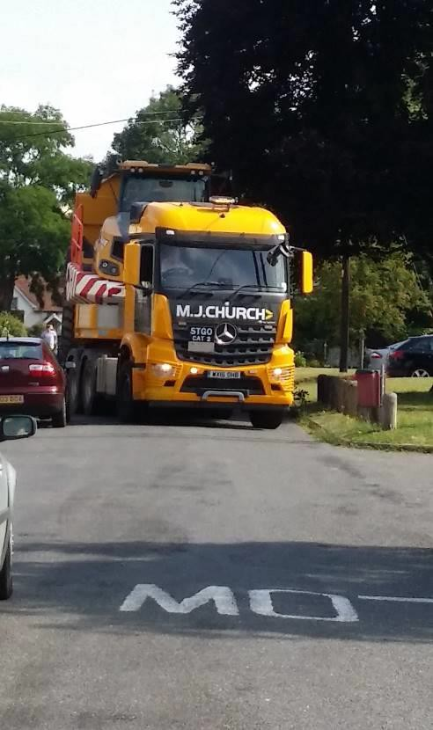
The Street, Bradwell village

Design
Design

To ensure high standards of design within new development
To support design which respects and enhances the Parish’s heritage and character

To ensure high standards of design within new development
To support design which respects and enhances the Parish’s heritage and character

Context

  - The Bradwell with Pattiswick Parish Village Design Statement provides a comprehensive description of the design of buildings through the Parish. There is a wide range of building designs throughout Bradwell and Pattiswick Parish. The character of the Parish as a whole is rural, however various areas have their own individual character and style of buildings. The north and south areas of the Parish include small dispersed hamlets with predominantly large residential dwellings on large plots of land, set back from the road. In the central area of the Parish is the village of Bradwell, which provides the largest settlement where existing development is focused around the A120, The Street, and Church Road. A number of small cul- de-sac developments are connected to the A120 and The Street. Existing residential development in Bradwell village is predominantly a mixture of detached and semi-detached low- density dwellings, usually with front gardens, off street parking, and large gardens to the rear.

  - Key relevant policies in the BDLP include:
    - Policy LPP 52 Layout and Design of Development.

Policy 10: Design

  - New development in the Parish should respond positively to the design, layout, scale, character, and appearance of existing development within the vicinity of any proposal site, and the rural character of the Parish.

  - The design of new development within the Parish should seek to protect the village identity, rural environment, and ambience, by ensuring that alterations and additions to existing buildings are sympathetic, and the use of materials reflect the existing character and appearance of the Parish.

  - The Neighbourhood Plan also requires new development to incorporate sustainable design features which promote energy efficiency to Passivhaus standards including solar PV panels, air-source heat pumps and mechanical ventilation heat recovery, biodiversity gains (such as built in bat boxes and swift hollow bricks), innovative low carbon technology, water efficiency, energy conservation and efficiency, flood resilience, sustainable waste and mineral management, and the provision of adequate amenity space to allow for vegetable gardens and small orchards. The Design and Access Statement supporting a planning application should therefore demonstrate how the sustainable design features, materials used, layout and building orientation contribute to creating a sustainable development.

Policy 10: Design
- All new development proposals should be of a high quality design which contributes positively to the character and appearance of the surrounding area and they should include a high-quality design which will contribute positively to the character and appearance of the surrounding area in accordance with the Bradwell with Pattiswick Parish Village Design Statement.

  - Demonstrate how the proposal will contribute positively to the existing rural character and appearance of the area as described in the Bradwell with Pattiswick Village Design Statement;
  - Ensure that the design reflects and responds positively to the scale, design, density, layout and historic character of existing development in the surrounding area, and will not result in significant harm to neighbouring residential amenity;
  - Ensure that the design, layout, scale, and appearance will not result in significant harm to heritage assets in the surrounding area, in accordance with BPNP Policy 5;
  - Be of a scale and size which reflects the rural character and appearance of villages and hamlets in the area;
  - Ensure that there is an appropriate use of materials which preserves and enhances the character of the area;
  - Be at a height which is in keeping with the character of the Parish and existing development surrounding the proposal site;
  - Incorporate sustainable design features which promote energy efficiency, biodiversity gains, innovative low carbon technology, water efficiency, energy conservation and efficiency, flood resilience, sustainable waste and mineral management;
  - Include an appropriate provision of off-street parking;

- Development proposals should where appropriate respond sensitively to the existing natural environment by:
  - Ensuring that the proposed layout protects and enhances important features of the natural environment and biodiversity of the site and its surrounds;
  - Retaining and protecting existing trees and hedges in and around the Parish wherever possible;
  - Incorporating the planting of trees, hedging and vegetation which is predominantly native and consistent with flora in the surrounding area. The planting of broadleaf species is encouraged to retain the leafy character of the Parish;
  - Retaining and maintaining grass verges, ideally incorporating native wildflowers which support local fauna; and
  - Including features within the design of the building which help declining species.

Relevant Evidence Base Documents

Bradwell with Pattiswick Parish Village Design Statement, 2018 Parking Guidance, Parking Standards and Good Practice, Essex Planning Officers Association, September 2024

Developer contributions

Context

  - When determining a planning application, BDC can seek contributions from developers to mitigate the impact of the development on the local area, known as developer contributions or planning obligations. The contributions can include financial contributions towards a range of infrastructure items such as community services and facilities, affordable housing, parks, play areas, public transport and community buildings, or the contribution can provide an item such as land, roads, constructed affordable housing and community buildings for example.

  - Key relevant policies in the BDLP include:

    - Policy LPP 31 – Affordable Housing; and
    - Policy LPP 78 – Infrastructure Delivery and Impact Mitigation.

Policy 11: Developer Contributions

  - The BDLP sets out some District-wide standards and guidance for developer contributions, informed and supplemented by the Infrastructure Delivery Plan and the Essex County Council Developers’ Guide to Infrastructure Contributions. However, these do not take into consideration all of the specific needs for Bradwell with Pattiswick Parish.

  - Policies within the BPNP have identified a range of infrastructure needs in the Parish which could be provided through developer contributions subject to viability. The potential developer contributions included within this Plan are summarised in Table 2 below.

Table 2: Potential developer contributions included within the BPNP
Local Infrastructure Requirements for Bradwell with Pattiswick Parish
- Maintaining an excellent network of footpaths by keeping them clear of vegetation.
- Improving off-road parking facilities in The Street and Forge Crescent.
- Improving pavements in Bradwell village.
- Restrictions of HGV movements in The Street.
- Road safety improvements such as 20mph speed limit, and speed checks.
- Safety improvements on the bends in The Street / Church Road, Bradwell village.
- Proposed speed limit reduction on the A120 from 40mph to 30mph.
- Road safety improvements to The Street / Coggeshall Road (A120) junction.
- Enhanced provision of Community Transport services.
- Extend the coverage and enhance the frequency of local village bus services in the locality.

  - Where appropriate, the Parish Council expect new development to contribute towards relevant infrastructure requirements identified in Table 2 when identifying contributions as part of an application. However, it is acknowledged that not all new developments will be able to contribute towards infrastructure needs in the Parish due to the financial viability of a scheme, and the particular infrastructure needs of the proposal. The need to provide developer contributions towards Parish based infrastructure requirements will be considered individually for specific development proposals. It is therefore recommended that developers consult with Bradwell with Pattiswick Parish Council and Braintree District Council at an early stage of preparing development proposals, to ensure that proposed developer contributions satisfactorily meet the requirements of the Neighbourhood Plan and the needs of the Parish.

Policy 11: Developer Contributions
- Where appropriate development will be required to contribute towards the provision of relevant infrastructure in the Parish and provide a proportionate contribution to the relevant projects identified in Table 2.

- Planning applications should where appropriate clearly demonstrate the impact of the proposed development on local infrastructure in the area, and demonstrate how developer contributions towards local infrastructure will satisfactorily mitigate the identified impacts.

Relevant Evidence Base Documents
Community Infrastructure Levy Regulations (HM Government, 2014) National Planning Policy Framework (HM Government, 2012)
Braintree Infrastructure Delivery Plan (Troy Planning & Design and Navigus Planning, 2017) Essex County Council Developers’ Guide to Infrastructure Contributions (Essex County Council, 2024)

Implementation

The Neighbourhood Plan Action Plan

  - The BPNP has identified a range of objectives within 7 topic areas, and set out 10 policies to enable the delivery of the objectives. The BPNP policies include a number of actions and projects to guide the delivery of Neighbourhood Plan objectives. Table 3 below considers in detail each action / project identified within the Plan, and outlines how the actions / projects will be delivered.

Table 3: The Neighbourhood Plan Action Plan
Ref | Action / Project | Relevant BPNP  Objective | How will this be delivered | Who is responsible | Outcome (Indicators of achievement) | Monitoring
2 | Maintaining an  excellent  network of  footpaths by  keeping them  clear of  vegetation. | To maintain  an excellent  network of  public  footpaths  and public  rights of  way  (including  byways and  bridleways) | Setting up a  group of  volunteers to  regularly check  and maintain  the paths. Joint  working with  ECC / BDC. | ECC  BDC  BPPC | A usable, clear,  and well  maintained  footpath  network  throughout the  Parish. | Undertaken by BPPC  and volunteers.  On-going
3 | Improving off- road parking facilities in The Street and Forge Crescent. | To improve off-road parking facilities in The Street and Forge Crescent | Discussions with ECC to identify options.  Could seek support through planning obligations where appropriate. | ECC BPPC | Identification of deliverable options.  Extend parking places in Forge Crescent. | Undertaken by BPPC and ECC.
4 | Improving pavements in Bradwell village. | To improve road safety by creating and safe road network, which is fit for purpose  To maintain an excellent network of public footpaths and public rights of way (including byways and bridleways) | Discussions with ECC to identify options.  Could seek support through planning obligations where appropriate. | ECC BPPC | Identification of deliverable options.  Delivery of improved pavements in Bradwell village notably Forge Crescent. | Undertaken by BPPC and ECC.
5 | Reduction of HGV  movements in The Street. | To improve road safety by creating and safe road network, which is fit for purpose | Discussions with ECC to identify options. | ECC BPPC | Construction of signs restricting HGV movements in The Street. | Undertaken by BPPC and ECC.
6 | Road safety improvements such as 20mph speed limit and speed checks. | To improve road safety by creating and safe road network, which is fit for purpose | Discussions with ECC to identify options.  Could seek support through planning obligations where appropriate. | ECC BPPC | Implementation of road safety measures. | ECC advise the Local Highways Plan 2025 may facilitate this
7 | Safety improvements on the bends in The Street / Church Road, Bradwell village. | To improve road safety by creating a safe road network, which is fit for purpose | Discussions with ECC to identify options.  Could seek support through planning obligations. | ECC BPPC | Mirror by Brunwins Cottages to improve visibility of on-coming cars | Undertaken by BPPC and ECC.
8 | Proposed speed limit reduction on the A120 from 40mph to 30mph | To improve road safety by creating and safe road network, which is fit for purpose | Discussions with Highways England. | Highways England BPPC | Reduction in the speed limit on the A120. | National Highways advise this is unlikely before the new A120 is complete
9 | Road safety improvements to The Street / Coggeshall Road (A120) junction. | To improve road safety by creating and safe road network, which is fit for purpose | Discussions with Highways England.  Could seek support through planning obligations. | Highways England BPPC | Identification of deliverable options.  Delivery of safety measures. | Advised to await the Local Transport Plan 2025  Meanwhile extension of the double yellow lines to full length of Waduds boundary to be persued with ECC
10 | Repairing Hollies Road water leak, and associated damage to road and roadside bank.. | To improve road safety by creating and safe road network, which is fit for purpose | ECC to further investigate and repair leak and associate damage to the road. | ECC | No further water leaks, standing water and mud at Hollies Road. | Undertaken by BPPC and ECC.
11 | Enhanced provision of community transport services. | To improve the provision of community and public transport | Parish Council to consider options through discussions with ECC.  Could seek support through planning obligations. | ECC BPPC | Identification of deliverable options.  Delivery of improved community transport services. | Undertaken by BPPC and ECC.
12 | Extend the coverage and enhance the frequency of local village bus services in the locality. | To improve the provision of community and public transport | Discussions with ECC to identify options.  Could seek support through planning obligations. | ECC BPPC | Identification of deliverable options.  Delivery of improved public transport provision. | Undertaken by BPPC and ECC.
13 | To engage with Essex County Council and Highways England to ensure potential impacts of the route choice for the new A120 are understood and mitigated sufficiently and the any direct or indirect benefits to the Parish are realised | To improve road safety by creating and safe road network, which is fit for purpose | Parish Council presence on relevant for a such as the A120 Braintree Community Forum and regular meetings with ECC Highways and Highways England | BPPC | Realisation of quantified benefits to the Parish | This is unlikely before RIS4, so completion is unlikely within the life-time of this Plan
14 | To seek to promote the identification and designation of a Conservation Area covering Bradwell village | To conserve and promote the heritage of the Parish | The Parish Council will build a case | BPPC | Designation of Conservation Area covering Bradwell village (or part thereof) | Undertaken by BPPC
15 | To improve safety of pedestrians, cyclists and horse riders on A120 at its junction with Hollies Road and Bridge Hall Road | To improve road safety by creating and safe road network, which is fit for purpose | Liaison between Parish Council and National Highways | National Highways | Schoolchildren inter alii will feel safe when crossing the A120 to catch the bus to school | Undertaken by BPPC
16 | To install White Gates at entrances to Bradwel Village on A120 ideaaly with speed cameras | To improve road safety by creating and safe road network, which is fit for purpose | Liaison between Parish Council and National Highways | National Highways | Schoolchildren inter alii will feel safe when crossing the A120 to catch the bus to school | Undertaken by BPPC
17 | To install safety cameras on the A120 Pelican crossing | To improve road safety by creating and safe road network, which is fit for purpose | National Highways Safety Scheme 2/25 | National Highways | Reduction in speeding vehicles through the village on the A120 | Undertaken by BPPC with National Highways and the police
18 | To reduce the speed limit on Church Road from 60mph to 40mph as far as the Church | To improve road safety by creating and safe road network, which is fit for purpose | Local Highways Panel  Case to be made by BPPC | Essex Highways | Improved safety for dog walkers along this stretch of road | Undertaken by BPPC
19 | To provide footpaths / cycleways as far as practical between Bradwell and Coggeshall and between Bradwell and Braintree | To improve road safety by creating and safe road network, which is fit for purpose | On-going discussion with National Highways and Braintree District Council | National Highways | Provides the ability for motorists to cycle or walk sfaely – improving the environment and their health | Undertaken by BPPC
20 | Public Spaces Protection Order (PSPO) | To support a cohesive, supportive community | Working with BDC and the police to establish the need for a PSPO | Local residents to report incidents of anti-social behaviour to BDC / police / Crimestoppers  BDC/police to implement PSPO | Reduction in anti-social behaviour around the Parish Church, Bluebell Wood and Sheepcoats Lane | Residents reporting incidents to the police / BDC / Crimestoppers facilitated by the Parish Council
21 | Neighbourhood Watch (NW) | To support a cohesive, supportive community | Parish Council will encourage volunteer NW co-ordinators; NW District will provide support | Parish Council / NW District support | Residents will acknowledge and participate in the Neighbourhood Watch scheme | Self-monitoring – this will be facilitated by the Parish Council

Abbreviations

BDC – Braintree District Council BDLP – Braintree District Local Plan
BPNP – Bradwell with Pattiswick Neighbourhood Plan BPPC – Bradwell with Pattiswick Parish Council
CIL – Community Infrastructure Levy ECC – Essex County Council
NPPF – National Planning Policy Framework

References
A120 Braintree to Marks Tey Improvement Phase 1 Habitat Survey, Hyder Consulting, July 2004

A120 to A12 Options Assessment Report, Essex County Council, Jacobs, April 2016

Bradwell History, Bradwell with Pattiswick Parish Council, 2017

Bradwell with Pattiswick Parish Plan, Bradwell Parish Council, June 2016

Bradwell with Pattiswick Parish Neighbourhood Plan Consultation Statement, 2018

Bradwell with Pattiswick Parish Village Design Statement, 2018

Braintree District Local Plan Section 1, Braintree District Council, 2021

Braintree District Local Plan Section 2, Braintree District Council, 2025

Braintree District Council Water Cycle Study, AECOM, March 2017

Braintree Infrastructure Delivery Plan, Troy Planning & Design and Navigus Planning, 2017

Braintree Open Space, Sports and Recreational Facilities Study, BDC, 2016

Braintree Open Space Study, BDC, 2016

Community Infrastructure Levy Regulations (as amended), HM Government, 2014

Essex County Council Developers’ Guide to Infrastructure Contributions, ECC, 2024

National Planning Policy Framework, HM Government, 2012

Open Spaces Action Plan, BDC, 2017

Property Inventory, Bradwell with Pattiswick Parish Council, 2017

Parking Guidance, Parking Standards and Good Practice, Essex Planning Officers Association, September 2024

Rural Community Profile for Bradwell Parish, RCCE, October 2013

The Braintree District Landscape Character Assessment, CBA, September 2006

United Kingdom Census 2011, Office of National Statistics, July 2012

Map 1: Local Wildlife Site: Links Wood (Bra146)
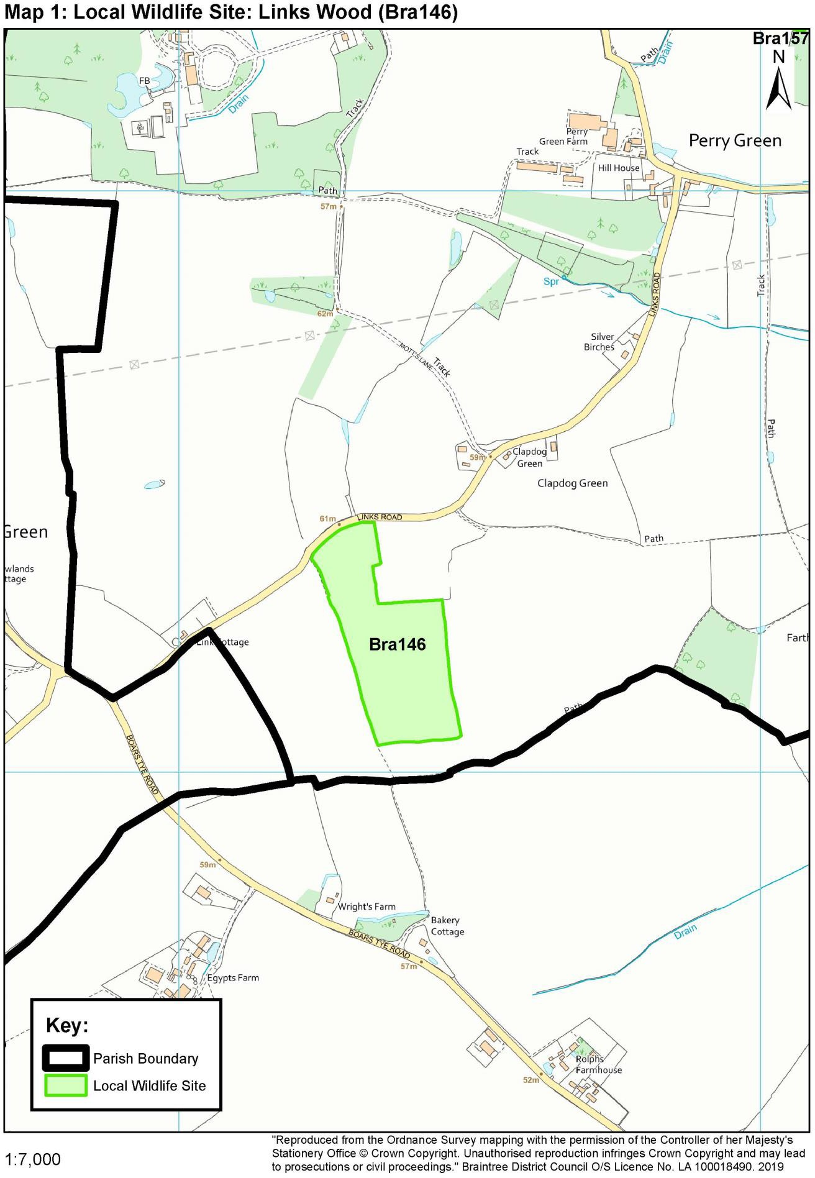

Map 2: Local Wildlife site: Park House Meadow (Bra157)
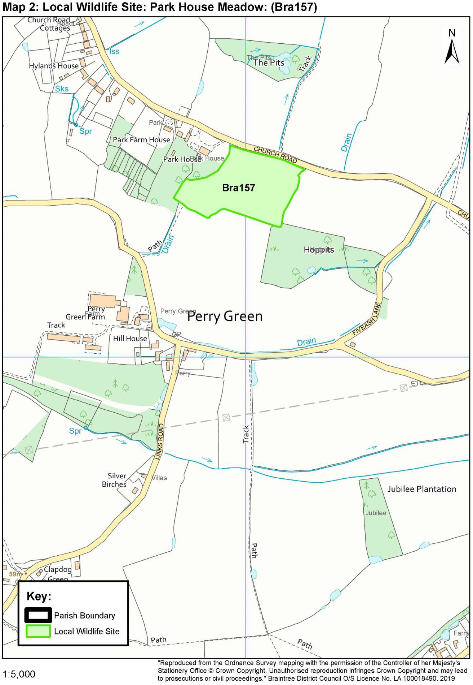

Map 3: Local Wildlife site: Blackwater Plantation West (Bra 158)
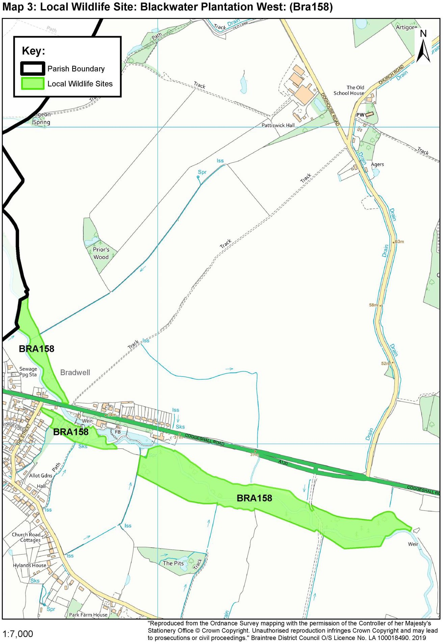

Map 4: Local Wildlife site: Blackwater Plantation (Bra186)
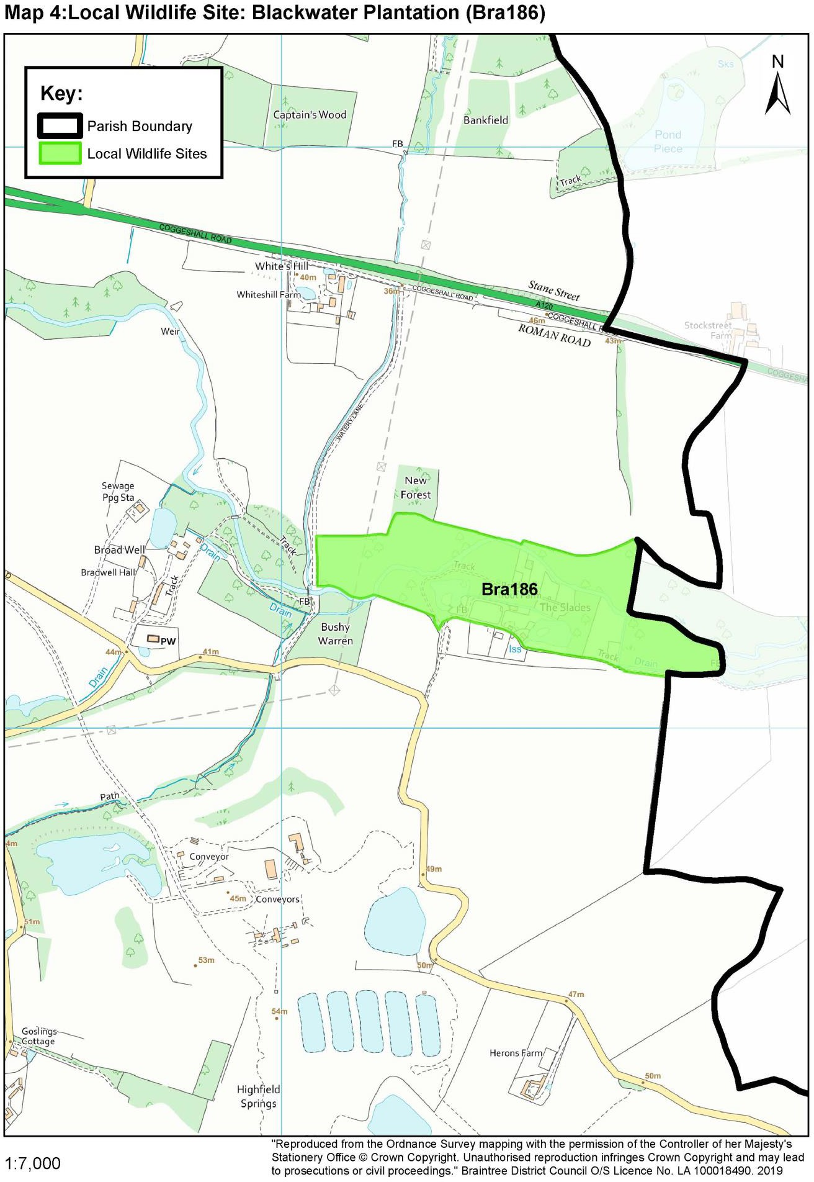

Map 5: Woodland: Century Piece (W1)
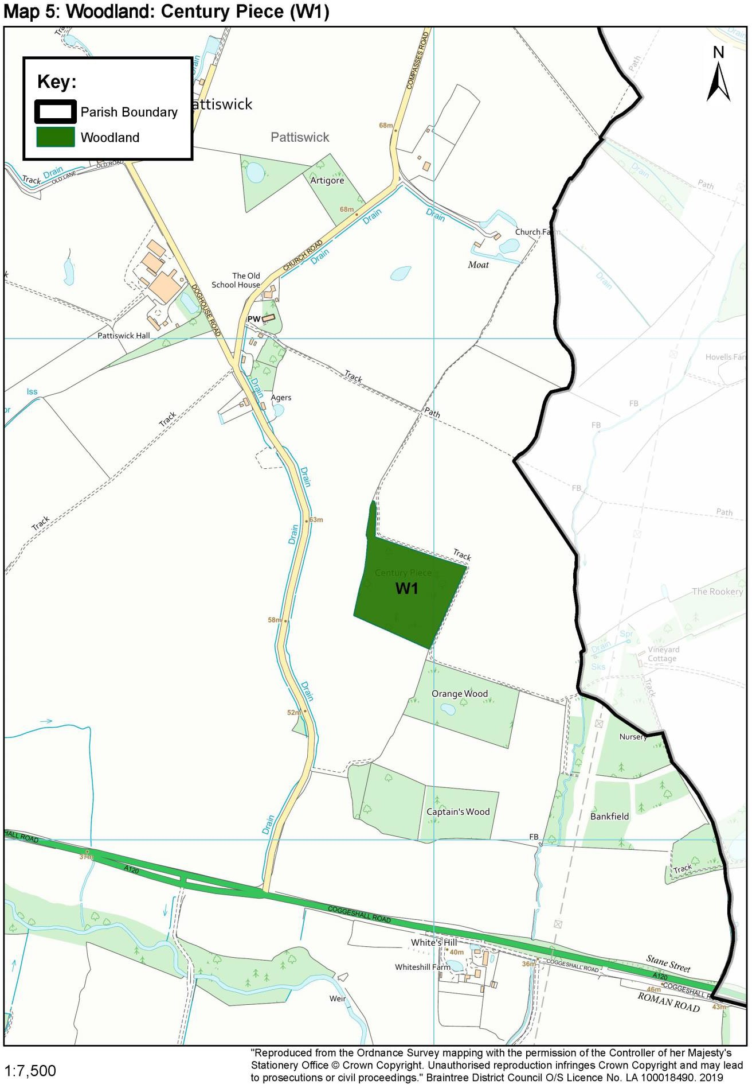

Map 6: Woodland: Orange Wood (W2)
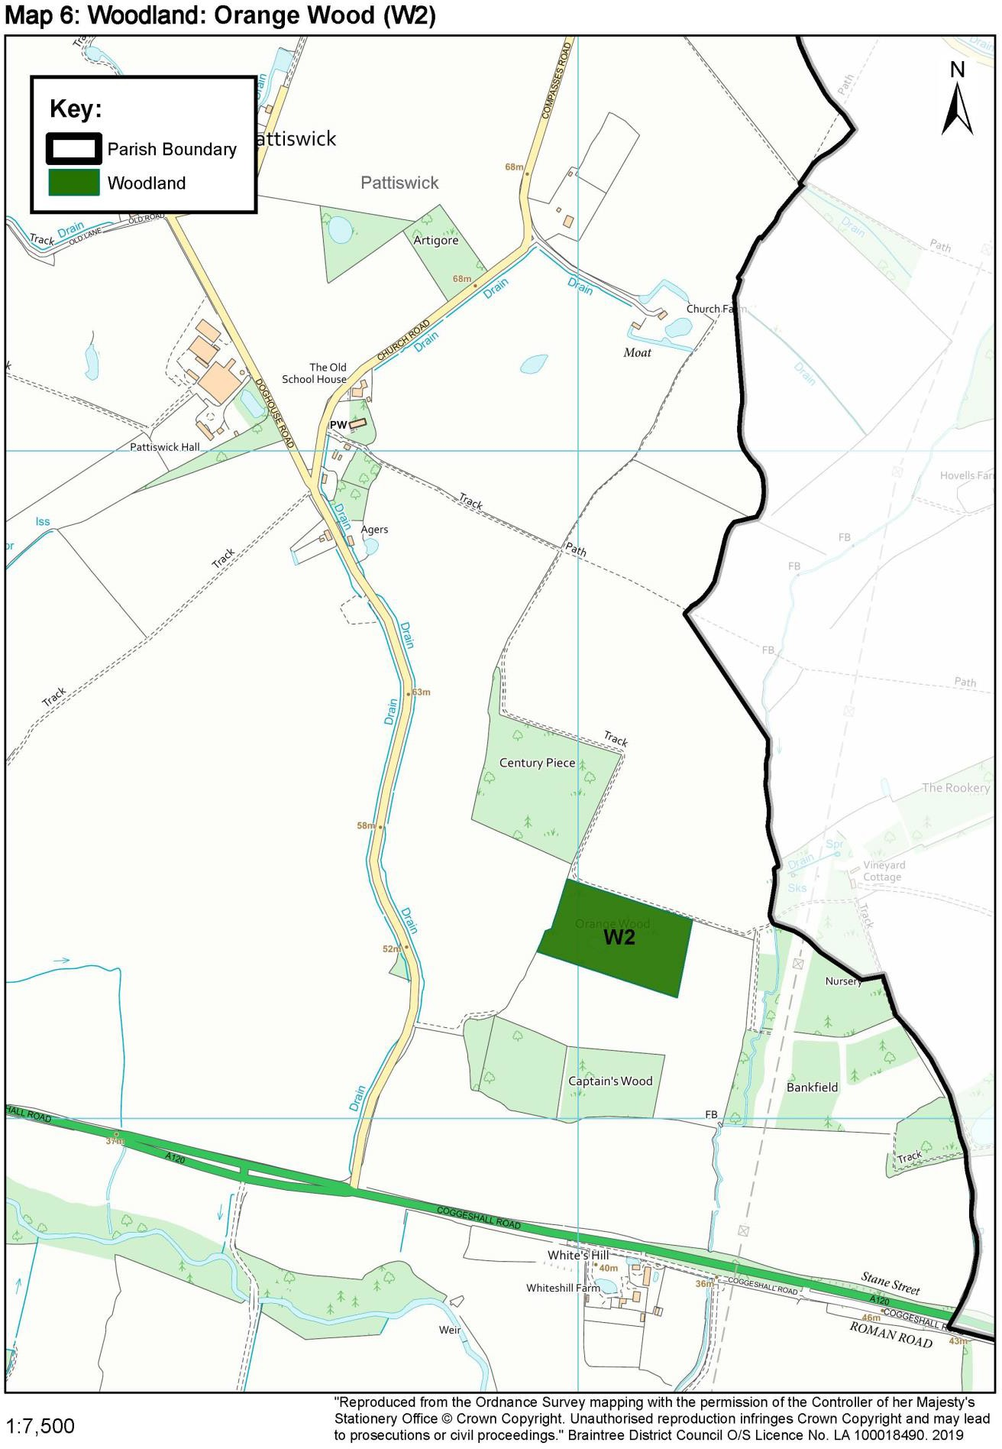
Map 7: Woodland: Captains Wood (W3)
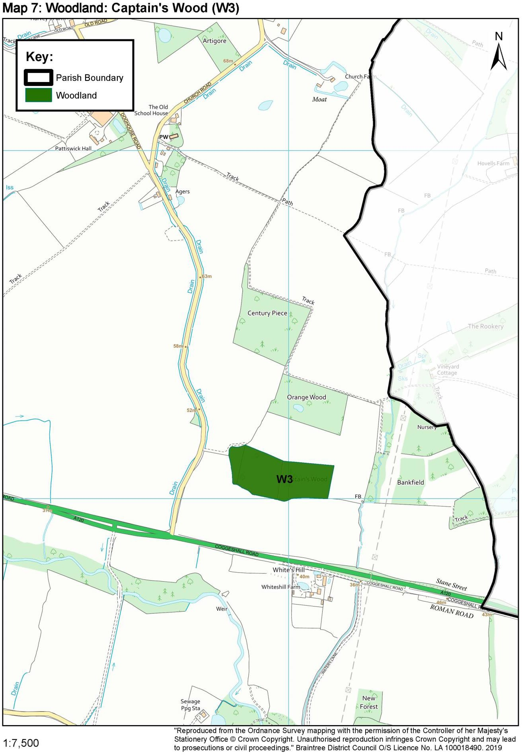
Map 8: Woodland: Bankfield (W4)
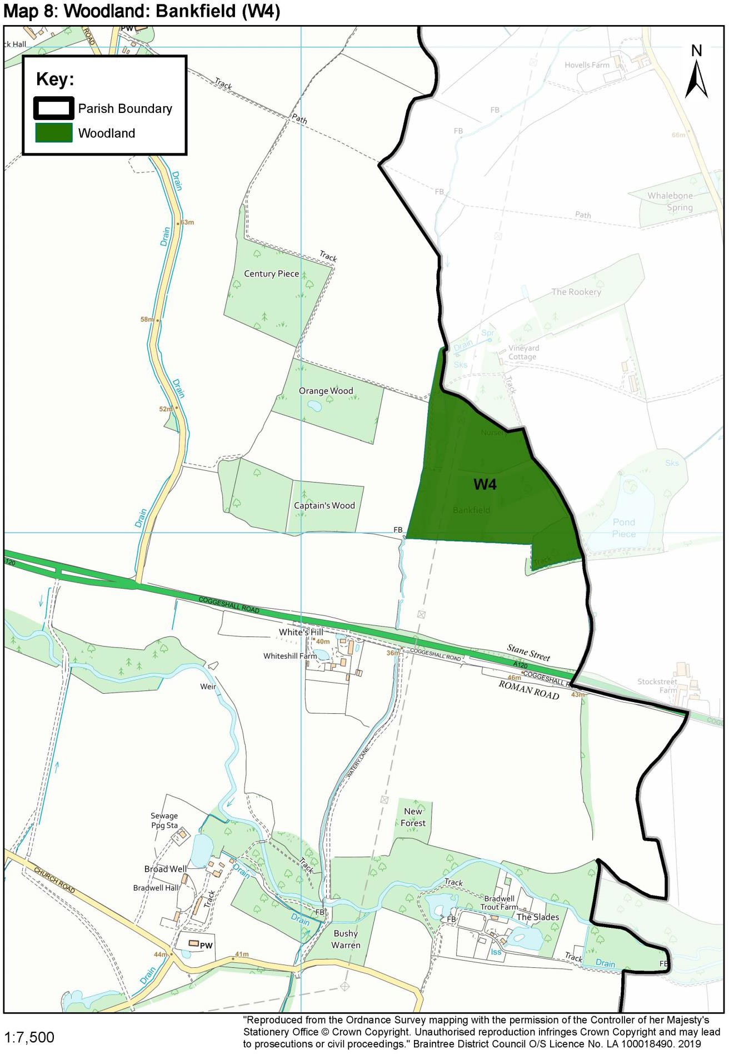

Map 9: Woodland: Bushy Warren (W5)
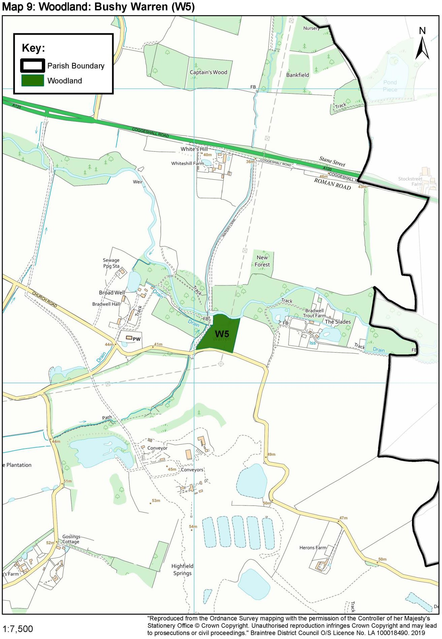

Map 10: Woodland: Artigore (W6)
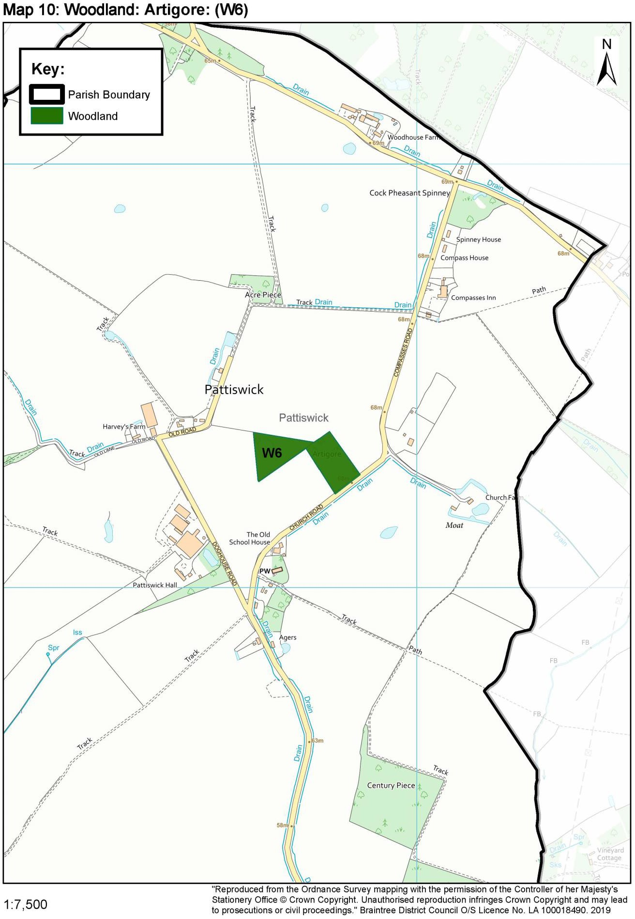
Map 11: Woodland: Cock Pheasant Spinney (W7)
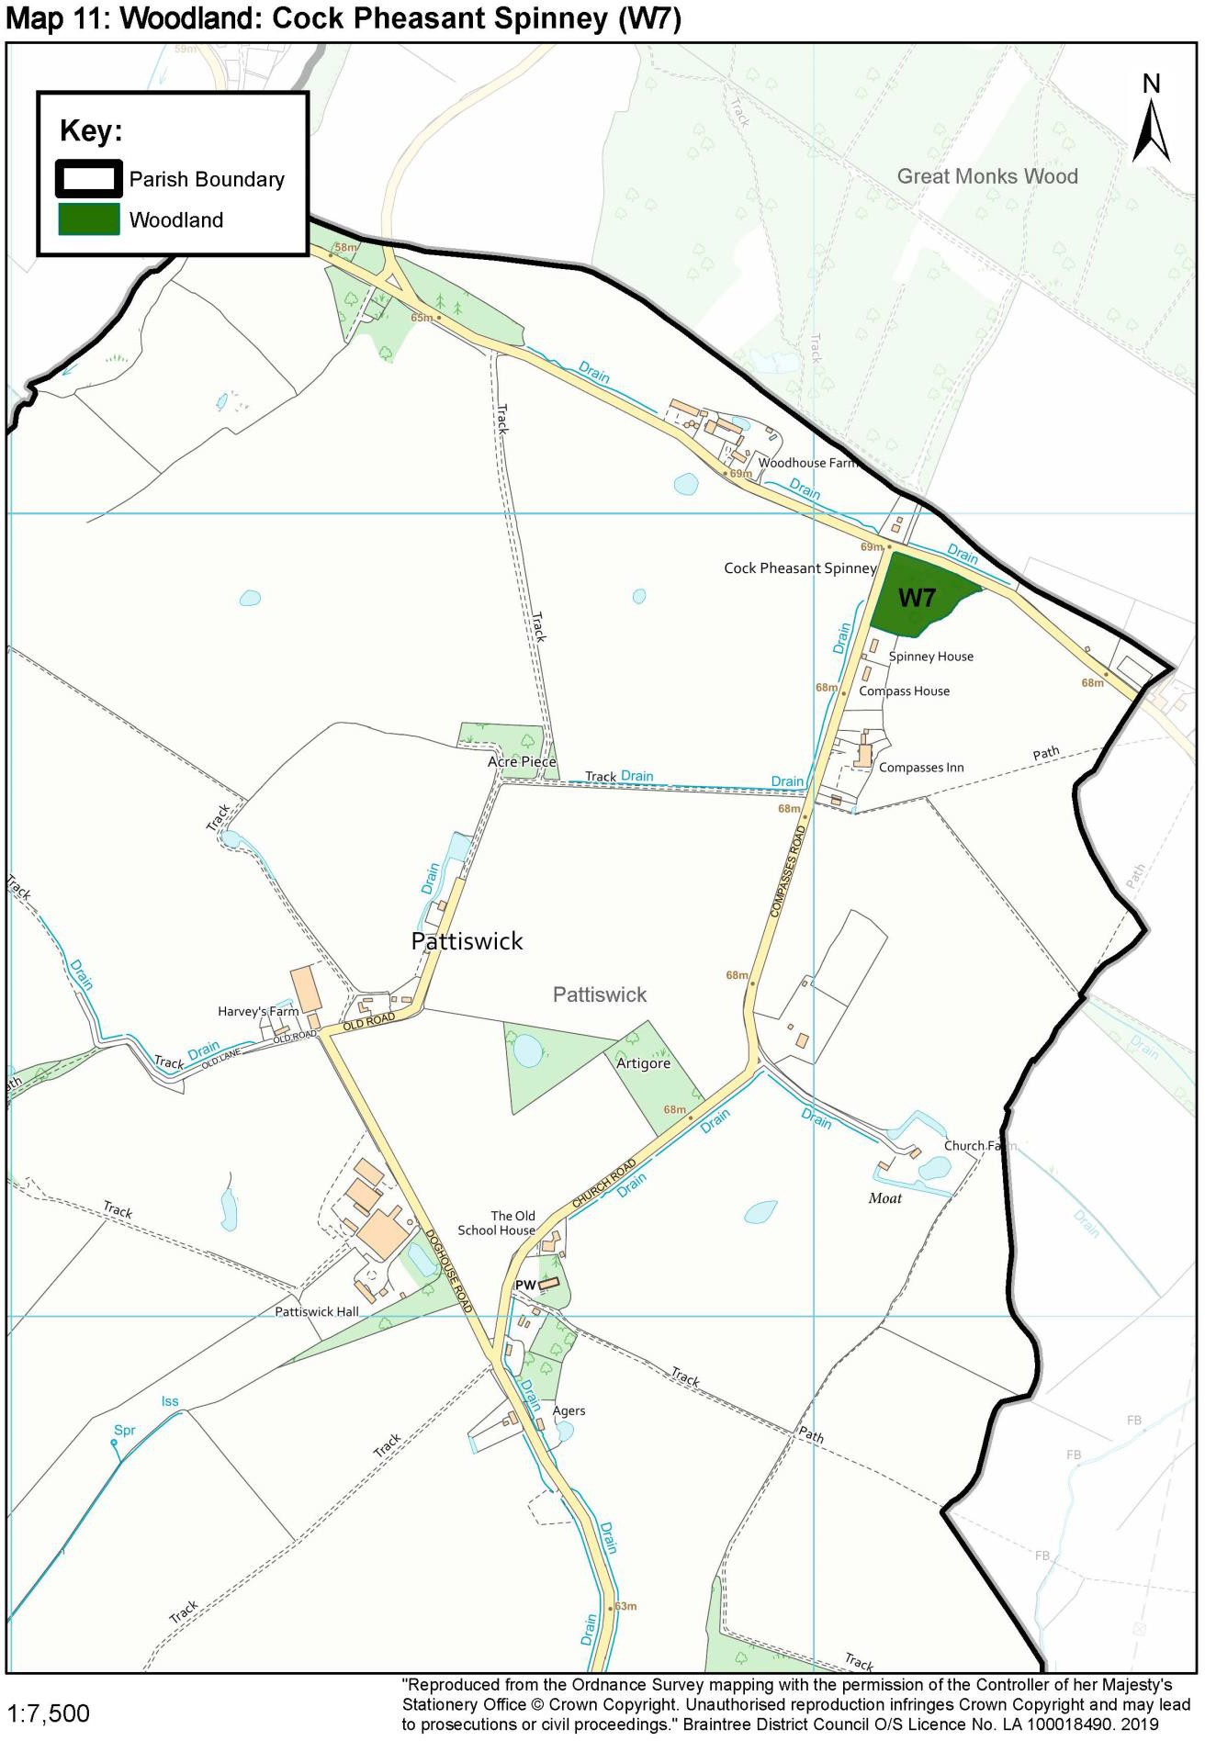
Map 12: Mill Pond
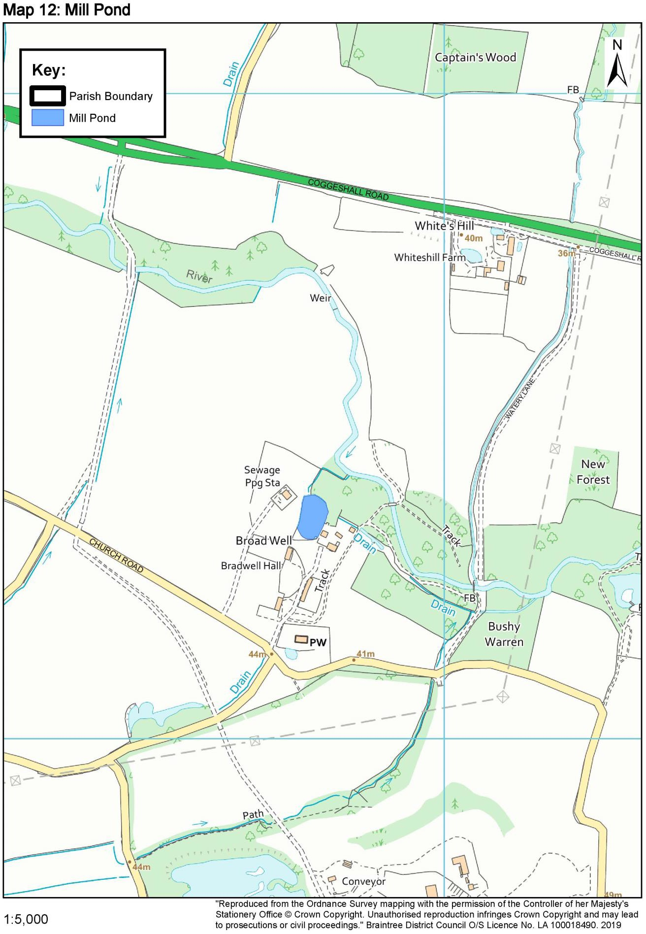

Map 13: Common Land: Land South of Holy Trinity Church
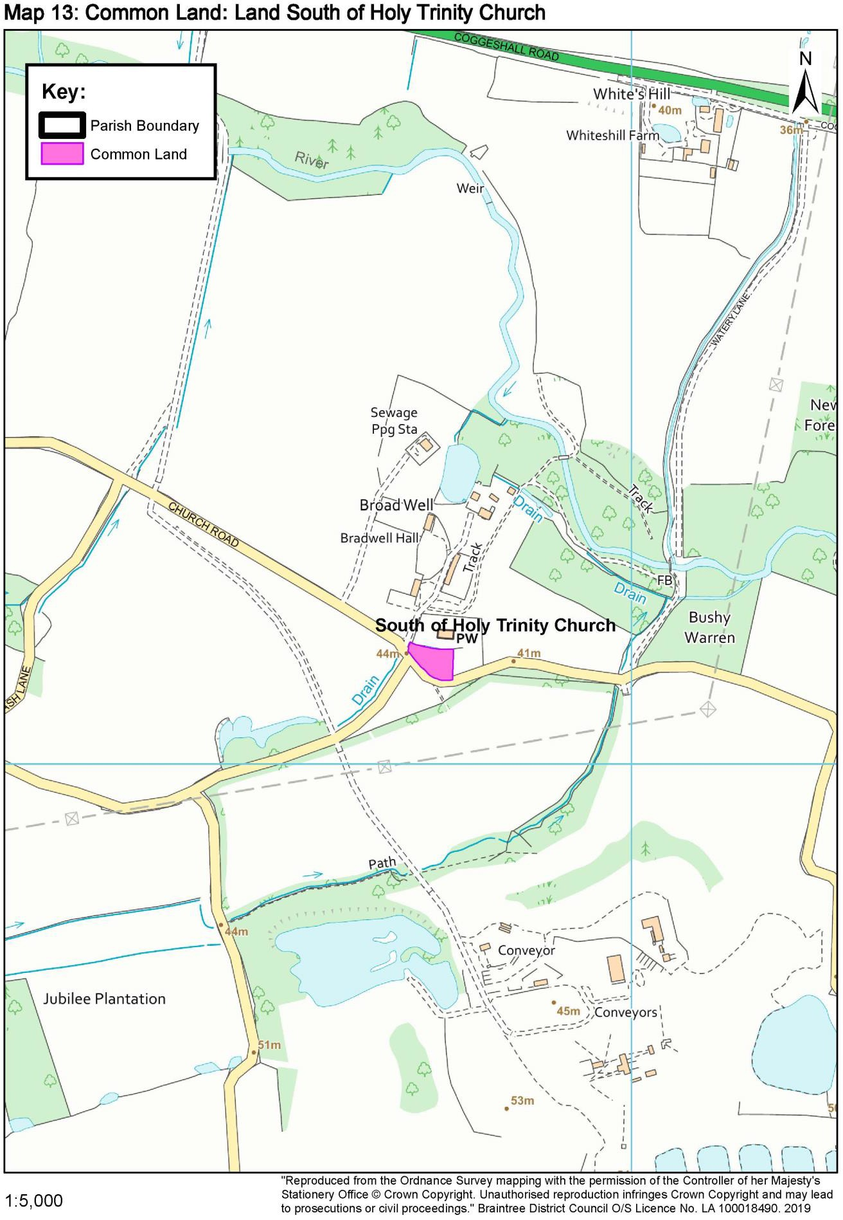

Map 14: Common Land: Land East of Bradwell Village
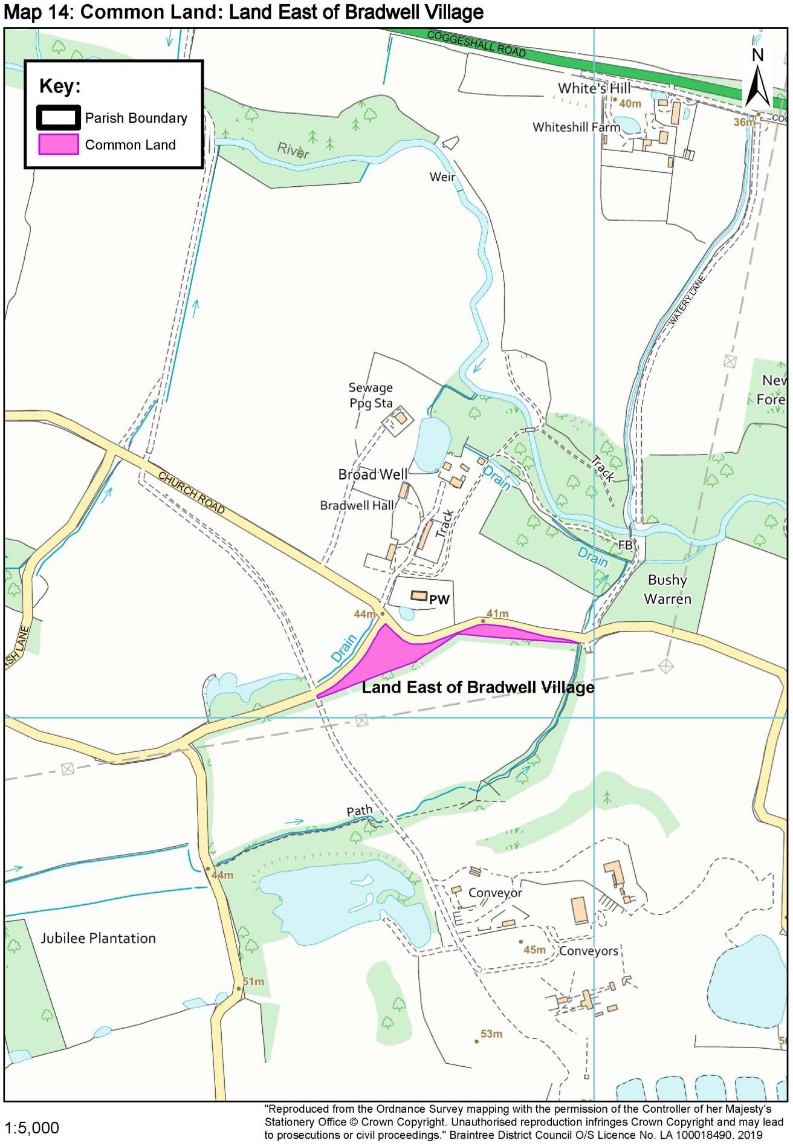

Map 15: Priority Habitat: The Street, Bradwell
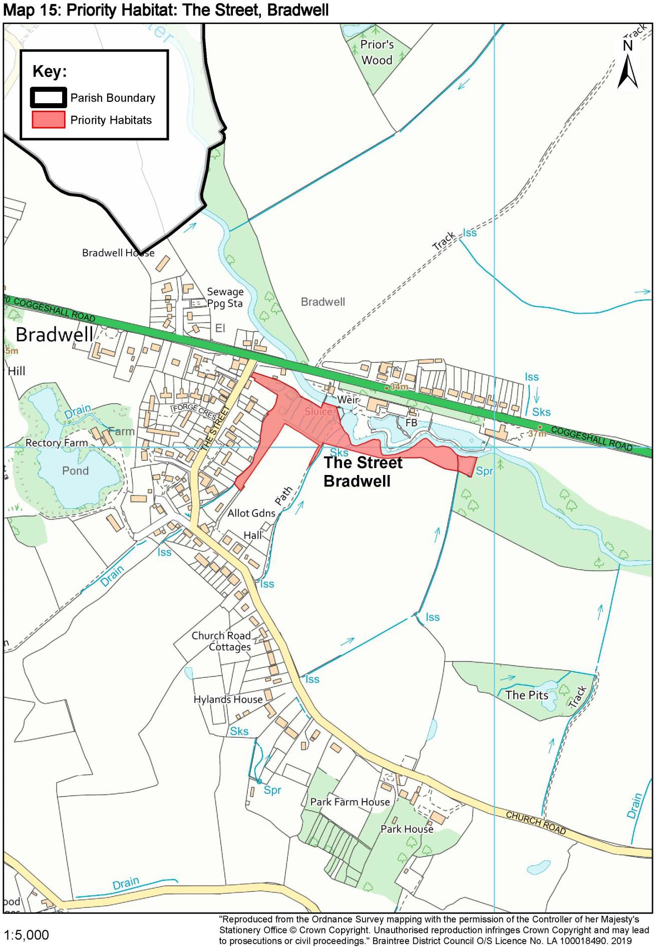

Map 16: Priority Habitat: Rectory Meadow, Bradwell
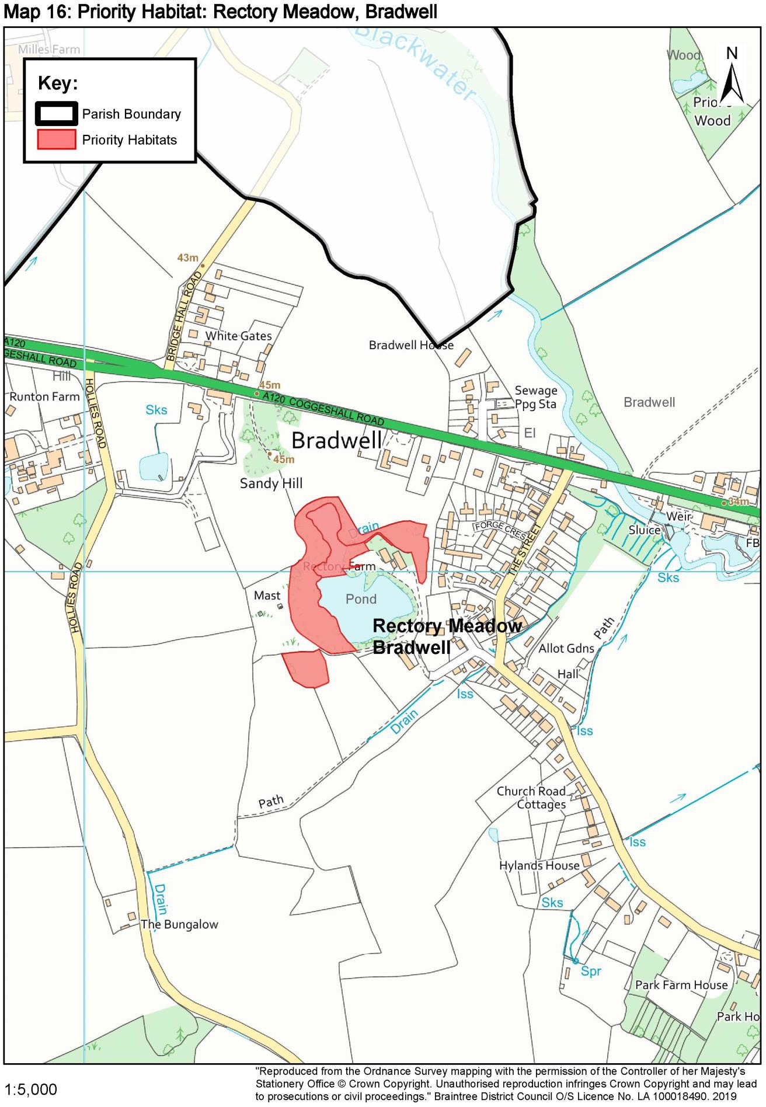

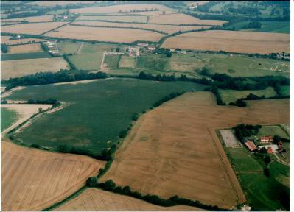
Annex 4
a. Cropmarks Baytree Farm and Withies Farm

a. Cropmarks Baytree Farm and Withies Farm

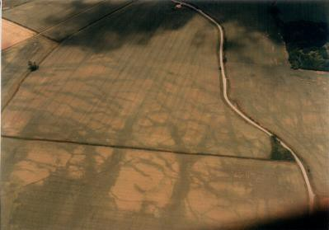
b. Cropmarks South of Pattiswick

b. Cropmarks South of Pattiswick
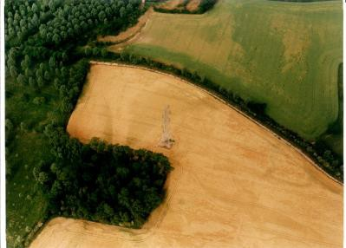
c. Cropmarks South of Whiteshill Farm

c. Cropmarks South of Whiteshill Farm
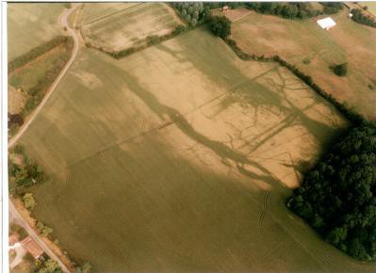
d. Cropmarks at Perry Green

d. Cropmarks at Perry Green
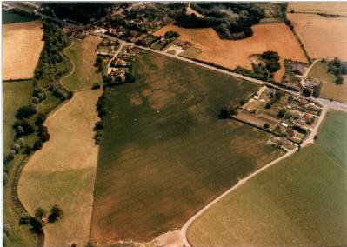
e. Cropmarks North-East of Bridge Hall

e. Cropmarks North-East of Bridge Hall
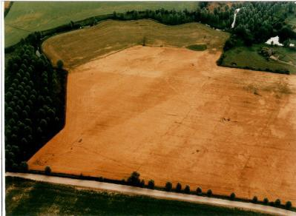
f. Cropmarks North-East of Bradwell Hall

f. Cropmarks North-East of Bradwell Hall
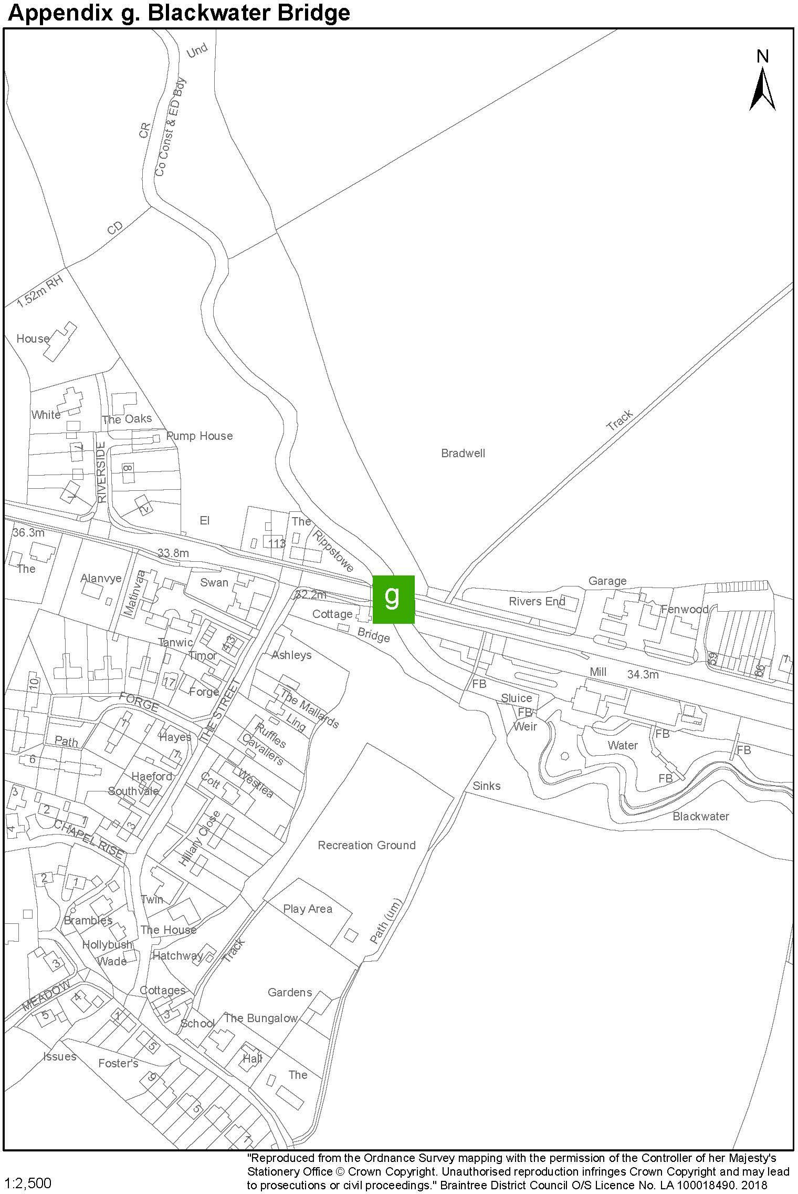
g. Blackwater Bridge

g. Blackwater Bridge
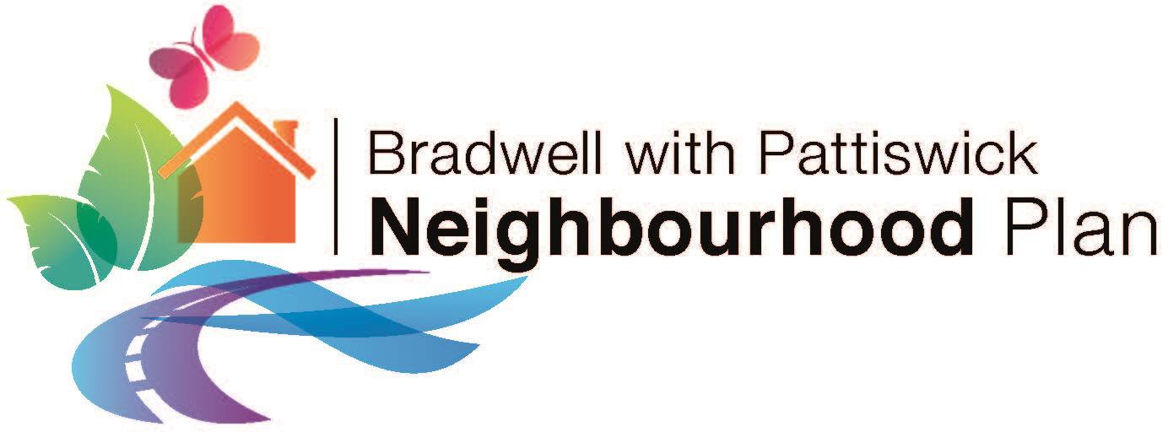

The Planning Practice Guidance (PPG) is an online portal which provides guidance on implementing aims and objectives of the NPPF. The PPG provides specific guidance on a range of planning related topics. www.gov.uk/guidance/neighbourhood-planning--2
www.gov.uk/guidance/neighbourhood-planning--2
Source: Ordnance Survey
Source: Braintree District Council, Publication Draft Local Plan
See the Neighbourhood Plan Evidence Base, available on the Bradwell with Pattiswick Parish Council website
Available in the Neighbourhood Plan evidence base on the Parish Council website.
Passivhaus is an approach to deliver net-zero-ready new and existing buildings. Passivhaus designed buildings seek to provide a high level of occupant comfort using very little energy for heating and cooling.
Existing settlements and hamlets in the Parish are Perry Green, Clapdog Green, Glazenwood, the hamlets around Pattiswick Church and The Compasses, the collection of buildings at Goslings Farm, the developments in Bridge Hall Road, Hollies Road and Riverside. Please refer to the Village Design Statement.
See the introductory sections of the Neighbourhood Plan.
A120 to A12 Options Assessment Report, Essex County Council, Jacobs, April 2016
See also the RSPB’s “Growing with Nature” ecology and landscape design guide.

